North Country Youth Turkey Hunt with an ECO, April 2016
Environmental Conservation Officers from Region 6 in Northern New York, and a few volunteers from the Northern New York Chapter of the National Wild Turkey Federation, took several youngsters hunting during the annual youth turkey hunting weekend. The event was hosted by the Watertown Sportsman’s Club, sponsored by the Federated Sportsman’s Clubs of Jefferson County and made possible by funding from the New York Conservation Officers Association and the Northern New York Chapter of the National Wild Turkey Federation.

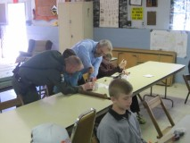
Once again the hunt was a two day event, with the first day being an instructional day and the second being the actual hunt day. The instructional day included some time in the class room covering basic information on wild turkeys, the rules and regulations pertaining to turkey hunting as well as covering the different types of calls, use of decoys, turkey hunting strategies, hunting preparation including scouting, and hunting safety. The day continued on the shooting range where some basic marksmanship skills were reviewed as well as shotgun patterning and some target practice.

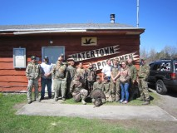
The following Saturday the young hunters met their hunting mentors for a day of hunting. The hunt day concluded with a picnic lunch and banquet back at the Watertown Sportsman’s Club where all the participants received a certificate of participation from the Federation Sportsman’s Club of Jefferson County.

