Fourth-graders get fun, but frosty, lesson at Delta Lake State Park
BY DAVE GYMBURCH Staff writer

Some fourth-graders from three Rome elementary schools got to spend part of Tuesday (March 3, 2015) at the lake, but it was not a typical day at the beach for them.
Trekking onto the frozen surface of Lake Delta with school staff and Rome Free Academy students, the elementary pupils took part in ice fishing through some holes in the thick layers. While the outing yielded just one fish, a 20-3” chain pickerel caught by Gansevoort school student Daniel Faes, it provided students with plenty of chances for a distinct learning experience.
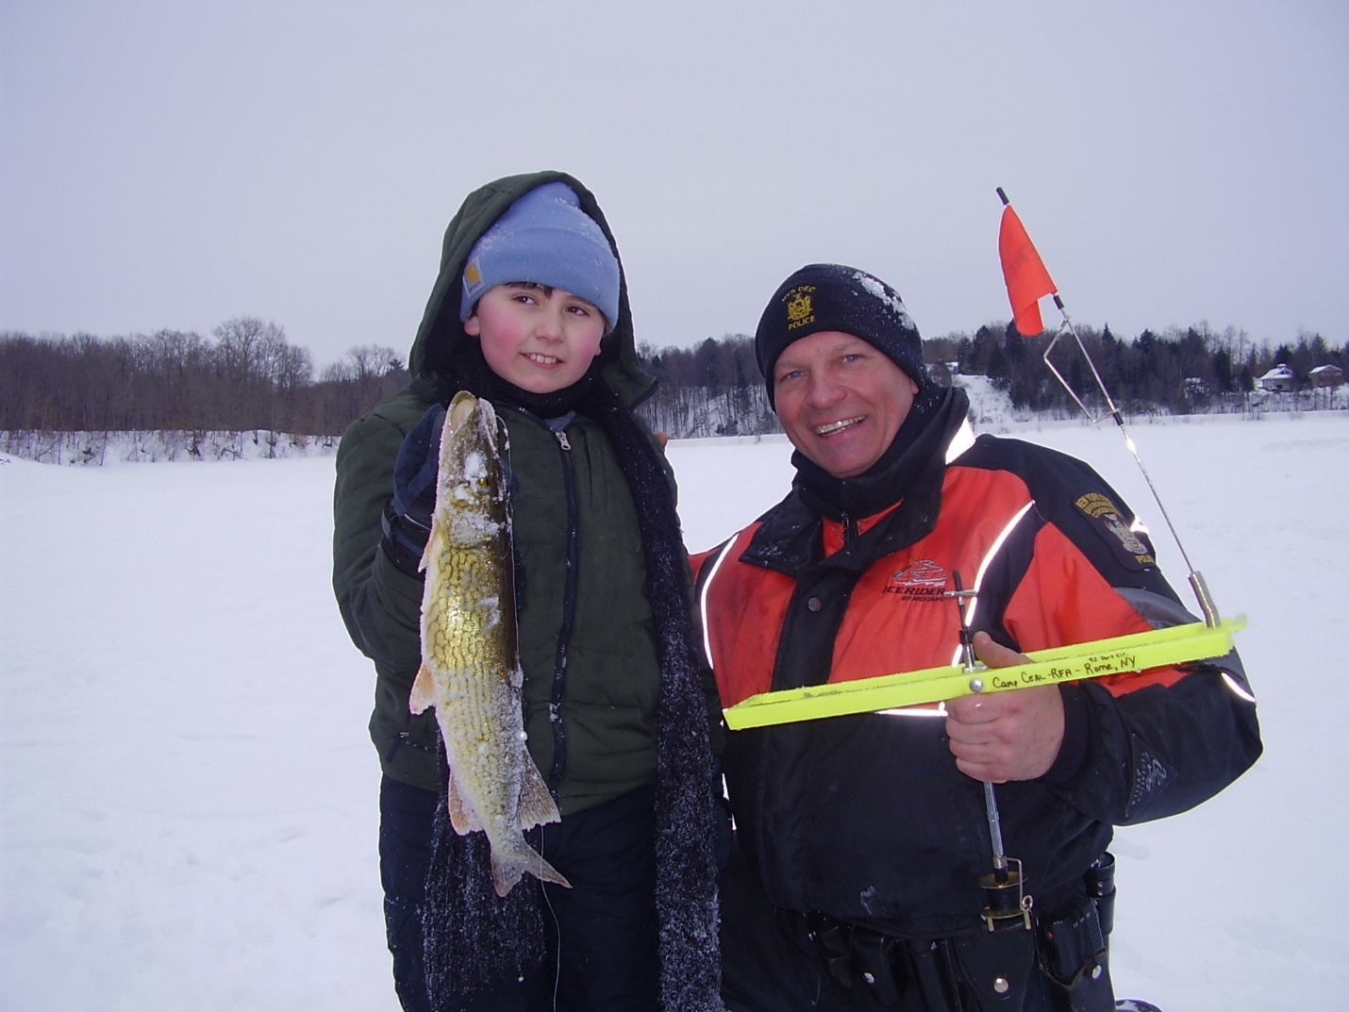
The event, which involved about 70 fourth-graders from Bellamy, Denti and Gansevoort schools plus about 15 RFA students, was part of the school district’s Camp CEAL (Character Education through Adventure Learning) program. The program includes fourth-graders from the three schools taking part in activities led by RFA students that are geared to reinforce character education skills, said Melissa O’Rourke, an RFA phys ed teacher and CEAL instructor; activities range from various games to “adventure” activities that include snowshoeing, aquatic skills at the RFA pool, and a hiking trip.
“The students had a great time. Unlimited smiles. They applied a tremendous amount of knowledge they learned throughout the day,” O’Rourke said of the ice-fishing trip. Students from the three elementary schools participated in the event during approximately 2-hour segments per school.
The ice-fishing outing was “a first for us,” said O’Rourke.
“We were looking for an additional activity to our snowshoeing adventure trip,” she explained. As central New York residents, “finding ways to enjoy the great outdoors is important to our physical and emotional health. With the waterways and open waters in our region, we are able to teach students how to safely participate in this accessible winter outdoor recreation activity.”
Topics during the outing included proper clothing; ice safety; ice fishing regulations; equipment; ice fishing techniques; and fish identification.
The fishing expedition, off the beach area at Delta Lake State Park, involved O’Rourke and fellow RFA phys ed teachers Mike Bartlett, Brett Couchman and Jerry Tabolt; RFA science teacher Sal Carollo; and RFA guidance counselor Ryan Tuggey. In addition, state Department of Environmental Conservation police officer Russell C. Ritzel was present.
