DEC Environmental Conservation Officer Highlights

ECO Actions for Early November
New York State Department of Environmental Conservation (DEC) Environmental Conservation Officers (ECOs) enforce the 71 Chapters of NY Environmental Conservation Law, protecting fish and wildlife and preserving environmental quality across New York.
In 2015, the 268 ECOs across the state responded to 25,000 calls and issued 22,000 tickets for crimes ranging from deer poaching to corporate toxic dumping and illegal mining, black market pet trade, and excessive emissions violations.
"From Montauk Point to Mount Marcy, from Brooklyn to Buffalo, the ECOs patrolling our state are the first line of defense in protecting New York's environment and our natural resources, ensuring that they exist for future generations of New Yorkers," said Commissioner Basil Seggos. "They work long and arduous hours, both deep in our remote wildernesses and in the tight confines of our urban landscapes. Although they don't receive much public fanfare, the work of our ECOs is critical to achieving DEC's mission to protect and enhance our environment."
Recent missions carried out by ECOs include:
Illegally Killed Eight-Point Deer - Rockland County
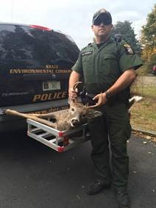
ECO Burdick with the illegally taken buck.
On Nov. 2, ECO Matt Burdick responded to a landowner's complaint of finding a gut pile on posted property in Chestnut Ridge. ECO Burdick located a blood trail leading to an adjoining property. The tracks and drag marks led him to an occupied tree stand with several piles of corn about 50 feet away from the stand and a gut pile about 100 feet from the stand. ECO Burdick ordered the hunter out of the tree stand. The man admitted that he had taken an eight-point buck earlier in the day. ECO Burdick accompanied the hunter to his home and seized the illegally taken buck. Five appearance tickets were issued to the hunter for illegal taking of big game, hunting deer over bait, trespassing, failing to wear a back tag, and failing to tag deer as required. The charges are pending in the Town of Ramapo Court.
Air Quality Violation - Kings County
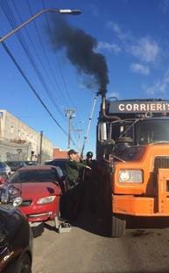
ECOs conducting an emissions
test on the truck.
On Nov. 4, ECOs Brian Gustitus, Paul Pasciak, and Kimberly Garnsey were on patrol in Kings County when they observed a heavy duty diesel vehicle emitting thick black smoke from its exhaust stack. The ECOs stopped the truck and conducted a smoke test, which indicated that the truck's average opacity rating was 85 percent, well above the legal limit for emissions. Upon further inspection of the vehicle, the ECOs found the vehicle had an expired HDDV Emission Inspection and was leaking diesel fuel and engine oil. Three summons were issued to the company that owns the vehicle, the driver stated that the issues would be addressed.
Two Deer, No License - Orange County
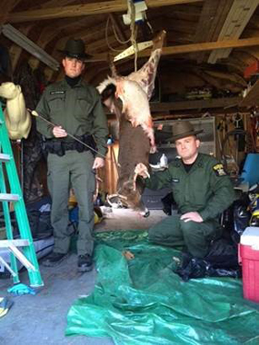
ECOs Lattimer and Kostuk with an illegally taken buck.
On Nov. 6, Lt. Mike Bello received a call reporting a hunter taking multiple bucks without a hunting license in the town of Hamptonburgh. Lt. Bello, along with ECOs Andrew Kostuk and Chris Lattimer, patrolled the property where the illegal deer was alleged to be stored. The ECOs arrived at the residence to find that the hunter was still in the process of butchering an untagged six-point buck in his shed. The hunter admitted that he had shot the deer that morning in his backyard with his bow and that he did not have a valid hunting license. The hunter also admitted that he shot another four-point buck approximately two weeks earlier and had it in his freezer. The defendant was issued multiple appearance tickets for illegally taking protected wildlife, taking big game in excess of the legal bag limit, and hunting big game without a license. All of the tickets are returnable to the Hamptonburgh Town Court.
If you witness an environmental crime or believe a violation of environmental law occurred please call the DEC Division of Law Enforcement hotline at 1-844-DEC-ECOS (1-844-332-3267).

