DEC Environmental Conservation Officer Highlights

ECO Actions for Early to Mid-November
New York State Department of Environmental Conservation (DEC) Environmental Conservation Officers (ECOs) enforce the 71 Chapters of NY Environmental Conservation Law, protecting fish and wildlife and preserving environmental quality across New York.
In 2015, the 268 ECOs across the state responded to 25,000 calls and issued 22,000 tickets for crimes ranging from deer poaching to corporate toxic dumping and illegal mining, black market pet trade, and excessive emissions violations.
"From Montauk Point to Mount Marcy, from Brooklyn to Buffalo, the ECOs patrolling our state are the first line of defense in protecting New York's environment and our natural resources, ensuring that they exist for future generations of New Yorkers," said Commissioner Basil Seggos. "They work long and arduous hours, both deep in our remote wildernesses and in the tight confines of our urban landscapes. Although they don't receive much public fanfare, the work of our ECOs is critical to achieving DEC's mission to protect and enhance our environment."
Recent missions carried out by ECOs include:
Just a Bag - Putnam County
ECOs Anthony Drahms and Dustin Dainack were patrolling a dirt road in the town of Southeast on Oct. 28 when they observed a large pile of solid waste that had been illegally dumped on the side of the road. The garbage bags contained tiles, drywall, cardboard, and other demolition debris, materials consistent with the renovation of a bathroom. The ECOs found evidence that revealed the construction materials had been purchased by a subject residing in Westchester County. ECO Drahms contacted the homeowner and asked if he had any remodeling done in the past few weeks. The homeowner said a bathroom was remodeled by a contractor and a local "handy-man," and that a waste hauler was hired to remove the debris. On Nov. 4, ECOs Drahms and Geoffrey Younglove conducted interviews that lead them to the contractor, who admitted to dumping "just a bag" of garbage at the site. He received a ticket for Illegal Disposal of Solid Waste returnable to Town of Southeast Court, and offered to clean up the waste immediately.
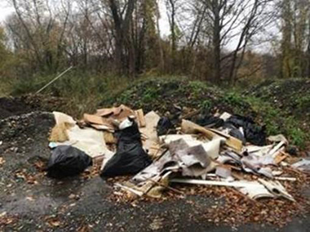
Illegally dumped construction debris in Putnam County.
Undersize and Over Limit - Richmond County
On Nov. 8, ECOs Waldemar Auguscinski, Mike Hameline and Jarrod Lomozik were on boat patrol in New York Harbor when ECO Auguscinski identified a vessel anchored within the Verrazano Bridge security zone. ECO Auguscinski piloted the DEC patrol vessel alongside the anchored vessel and identified two men fishing. After directing the fisherman to a safer location, ECOs Hameline and Lomozik boarded the vessel and performed a compliance check. The ECOs found the men in possession of 12 Blackfish, eight of which were under the legal size limit of 16 inches. The undersize fish were seized and summonses were issued for possession of undersize blackfish and possession of over the daily catch limit of blackfish, returnable to Richmond County Court.
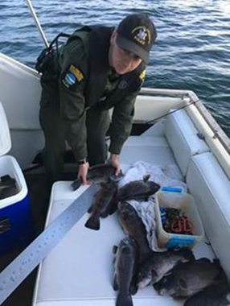
ECO Hameline measuring fish.
Attempted Deer Jacking - Schuyler County
On Nov. 8, ECO Erik Dalecki received a call from a Schuyler County Sheriff Deputy regarding an attempted deer jacking at 1 a.m. in the town of Hector. While responding to a call of shots fired and spotlighting, the deputy found a truck matching the description from the complainant, as well as a loaded rifle at the scene. ECO Dalecki seized the evidence and investigated the case. ECO Dalecki located and interviewed an 18-year-old male, who admitted to using an artificial light to hunt for deer, shooting from a public highway, having a loaded long gun in a motor vehicle, using rimfire ammunition to hunt deer, and hunting deer during closed hours. The subject, who had used a .22-caliber Marlin rifle belonging to his grandfather, was issued five tickets for the offenses, three of which are misdemeanors. ECO Dalecki then interviewed a 16-year-old male subject with his mother present, and later issued the same five tickets for being an accessory. Both subjects face maximum fines of up to $5,500 in penalties.
Flat Tire Poachers - Kings County
On the evening of Nov. 9, ECOs Kevin Cummings, Evan McFee, and JT Rich were driving down the Belt Parkway when they noticed two vehicles parked along the highway during the rainy, rush hour traffic. The ECOs stopped to assist the disabled vehicle with a flat tire. They noticed a cooler in the road behind one vehicle and asked the five men what it contained. The men replied, "fish," and proudly lifted the lid to show the ECOs. The individuals were informed they would be checked for the fish they had caught that day once in a safer location. The stranded motorists were led to the nearest exit so they could safely change their tire out of harm's way and ECOs could inspect the fish. ECOs went through a total of seven full-size coolers of black sea bass and scup. The individuals had come from Montauk that afternoon with charter boat receipts, and had purchased fish from the Captain. After more than an hour of inspections, the ECOs found the individuals had 76 black sea bass that were under the 15-inch size limit and 26 that were over the allowed legal limit. In addition, the individuals were in possession of 28 scup under the 10-inch size limit. The ECOs issued a total of 15 summons to the five individuals and donated the 104 illegal fish to a homeless shelter in Manhattan.
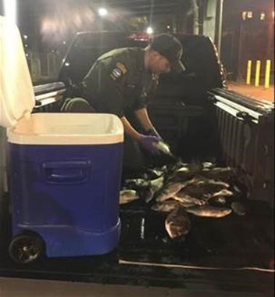
ECO JT Rich sorting through the illegal fish.
Unplugged and Uneducated - Orange County
On Nov. 13, ECOs Melissa Burgess and Robert Hodor were patrolling Stewart State Forest in New Windsor looking for hunting violations. A hunter pulled up alongside ECO Burgess' vehicle to ask several questions about regulations in the state land. The man had been out duck hunting earlier in the day and had shot a green winged teal. While checking his hunting license, ECO Burgess discovered that the man did not have his duck stamp signed, resulting in her issuing a verbal warning and educating the hunter on the requirement to have a signed duck stamp. When asked about the shotgun he had been hunting with, the hunter admitted to not knowing if the gun had a plug in it or not. Upon inspection, the shotgun was found to hold more than the legal capacity limit of three shells. The hunter was issued a ticket for hunting waterfowl with a shotgun capable of holding more than three rounds of ammunition.
Big Buck Poachers Face Multiple Charges - Erie County
On Nov. 19, two men in Cheektowaga decided they were going to get an early - and illegal -start to the shotgun season. They got a crossbow and headed toward an area where deer frequent a residential neighborhood. At about 1 a.m., one of the men spotted a 10-point buck standing alongside Strasmer Drive and fired the crossbow over the road, apparently gut-shotting the buck. Cheektowaga police were called by a concerned neighbor who saw flashlights in her yard. Upon the arrival, a foot chase ensued and one individual was caught while the other was able to flee. Cheektowaga Police then contacted ECO Robert Peinkofer.
Illegally shot buck.
ECO Peinkofer conducted a lengthy search and investigation that continued well into the next day. Deer Search, Inc., a non-profit group of volunteers that track dead deer, was called and on Nov. 20, Deer Search's Gary and Kari Huber and their K-9s Kita and Beya picked up a scent. ECOs Scott Marshall, James Hunt, and K-9 Bear were also on scene when the buck was located in a swamp. Multiple interviews were conducted with the poachers and they admitted to shooting the deer. A total of 13 tickets were issued to the young men.
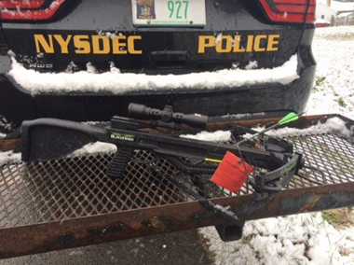
Seized crossbows
If you witness an environmental crime or believe a violation of environmental law occurred please call the DEC Division of Law Enforcement hotline at 1-844-DEC-ECOS (1-844-332-3267).

