DEC Environmental Conservation Officer Highlights

ECO Actions for Early to Mid-November
New York State Department of Environmental Conservation (DEC) Environmental Conservation Officers (ECOs) enforce the 71 Chapters of NY Environmental Conservation Law, protecting fish and wildlife and preserving environmental quality across New York.
In 2015, the 268 ECOs across the state responded to 25,000 calls and issued 22,000 tickets for crimes ranging from deer poaching to corporate toxic dumping and illegal mining, black market pet trade, and excessive emissions violations.
"From Montauk Point to Mount Marcy, from Brooklyn to Buffalo, the ECOs patrolling our state are the first line of defense in protecting New York's environment and our natural resources, ensuring that they exist for future generations of New Yorkers," said Commissioner Basil Seggos. "They work long and arduous hours, both deep in our remote wildernesses and in the tight confines of our urban landscapes. Although they don't receive much public fanfare, the work of our ECOs is critical to achieving DEC's mission to protect and enhance our environment."
Recent missions carried out by ECOs include:
Exotic Bird Seizure - New York County
On Nov. 10, ECO Adam Johnson received information from Region 2 investigators regarding the sale of a White Cockatoo taxidermy mount from a store in Lower Manhattan. The White Cockatoo is a threatened species, therefore making it illegal to possess or sell any part of the bird. Officers Johnson, Spencer Noyes, and Wes Leubner went to the store where the White Cockatoo was on display along with numerous exotic animal mounts. After confirming the store had no permit to possess or sell the White Cockatoo mount, the bird was seized and the owner of the store received two summonses for illegal commercialization of wildlife and the possession/sale of threatened or endangered species or parts.
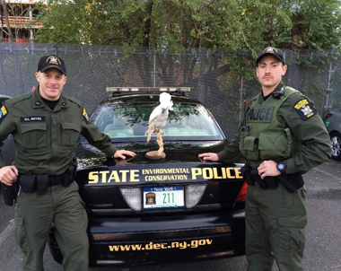
ECOs Noyes and Johnson with the illegal White
Cockatoo taxidermy mount.
Lake Ontario Tributaries Popular for Illegal Fishing - Monroe County
On the night of Nov. 11, Lt. William Powell, ECOs Brian Wade, John Lutz, John Stansfield, Todd Smith, Eoin Snowdon, and Joshua Wolgast conducted a saturation patrol in response to complaints of subjects sneaking into Lake Ontario tributaries to spear and net spawning trout. It was a busy night and by 4 a.m. the following morning, ECOs apprehended seven individuals from Rochester, New York City, and New Jersey, seized 16 illegal fish, and wrote a total of 18 tickets for taking over the limit of brown trout, taking fish by means other than angling (spearing), fishing during closed hours, failing to comply with the lawful order of a Conservation Officer, and trespassing. Three coolers full of fish were seized as evidence and all subjects were issued tickets returnable to the Town of Webster Court.
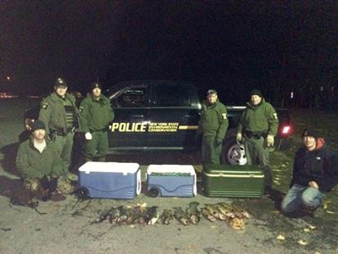
ECOs with illegally taken trout.
Striped Bass Seizure - Kings County
On Nov. 16, ECOs Mary Grose, John Walraven, Chris Macropoulos, Jeff Krueger, and Brad Buffa were patrolling Gerritsen Creek in Kings County on a DEC Police patrol boat when they encountered a boat returning to port. The captain of the boat stated he had two striped bass on board and quickly showed the fish to the officers. However, further inspection of the vessel located 12 additional striped bass in a mesh bag that also contained a weighted PVC pipe. Grose interviewed the captain and determined that he was a commercial fisherman, although he did not have the necessary carcass tags and other paperwork. The ECOs issued the captain summonses for possession of untagged striped bass, possession of striped bass out of the slot limit, failure to have a VTR, and failure to provide his food fish permit.
Hunting Deer with Bait ... Again! - Sullivan County
On Nov. 19, just before dusk, ECOs Bob Hodor, Matt Burdick, Melissa Burgess, Lt. Mike Bello, and a New York State Police Trooper concluded an investigation involving a hunting camp in the town of Fallsburg. Members of the family camp had been ticketed in 2013 after an investigation revealed that all of the ground blinds and tree stands associated with the camp were heavily baited for the purpose of attracting deer. Earlier this fall, ECOs Hodor, Burgess, and Lt. Bello revisited the camp and found that the hunters were still using bait. This year's investigation resulted in the ticketing of five hunters, all for the violation of hunting deer with the aid of pre-established bait.
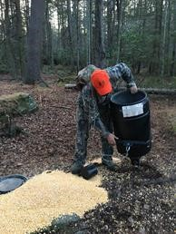
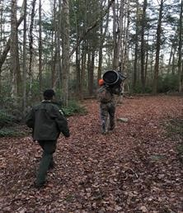
ECO Burgess and one of the
hunters removing illegal deer
feeder.
Trespasser With Too Many Tags - Putnam County
On Nov. 19, ECOs Craig Tompkins and Tony Drahms followed up on a trespassing complaint reported the day before in the town of Southeast. ECO Tompkins responded and confirmed that the land was legally posted, but also located a tree stand on the property. Returning to the location the following day, the ECOs observed a subject walking from the tree stand on the posted property. As it turned out, the man was tracking a deer he shot while trespassing. During the interview with the subject, ECOs determined the man was in possession of his brother's DMP tags and bow/muzzleloader tag as well as his own. The hunter was issued tickets for trespassing on posted property, illegal taking of protected wildlife (deer), and possessing the license of another person. A small buck and the brother's tags were seized as evidence and the tickets are returnable to the Southeast Town Court.
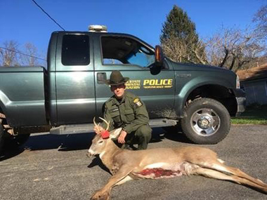
ECO Tompkins and the illegally killed buck.
Trespassing to Hunt - Broome County
On Nov. 19, ECO Andy McCormick responded to a complaint in the town of Union regarding a group of hunters trespassing on private property. The complainant stated that he had confronted the men and the discussion nearly became violent. The group did not have permission to be on the property. Officer McCormick checked the area and attempted to locate the responsible parties, but found no signs of them. On Nov. 20, the complainant contacted ECO McCormick again, advising him that two of the hunters had returned to hunt the same property. Both ECOs McCormick and Anthony Rigoli responded, tracked the two on the property, and found them hunting again. Both subjects were ticketed for trespassing and were advised not to return.
Lots of Tags But Too Early to Shoot - Saratoga County
On the morning of Nov. 20 at 7 a.m., the opening weekend of the Southern Zone regular season for deer hunting, ECOs Rob Higgins and Steve Shaw responded to a call from a complainant who had witnessed a man shoot at a group of deer in the dark approximately 30 minutes before the start of legal hunting hours. The complainant confronted the hunter and his father about the legality and danger of the incident, but the two men scoffed at the subject. The ECOs found the deer that the hunter had shot - a nine-point buck field dressed at 210 pounds. The hunter and his father were interviewed and ECOs verified that the taking was illegal. The man who shot the deer was issued tickets for hunting deer during closed hours and killing a wild deer except as permitted by the Conservation Law. The deer was seized as evidence and donated to the Saratoga County Venison Donation Program. All charges are pending in the Town of Ballston Court.
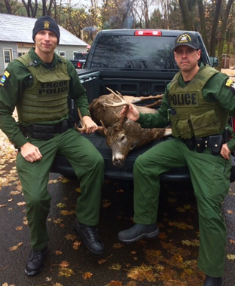
ECOs Higgins and Shaw with the illegally
taken buck.

