Bella Antiques
-ECI Edward J. Piwko
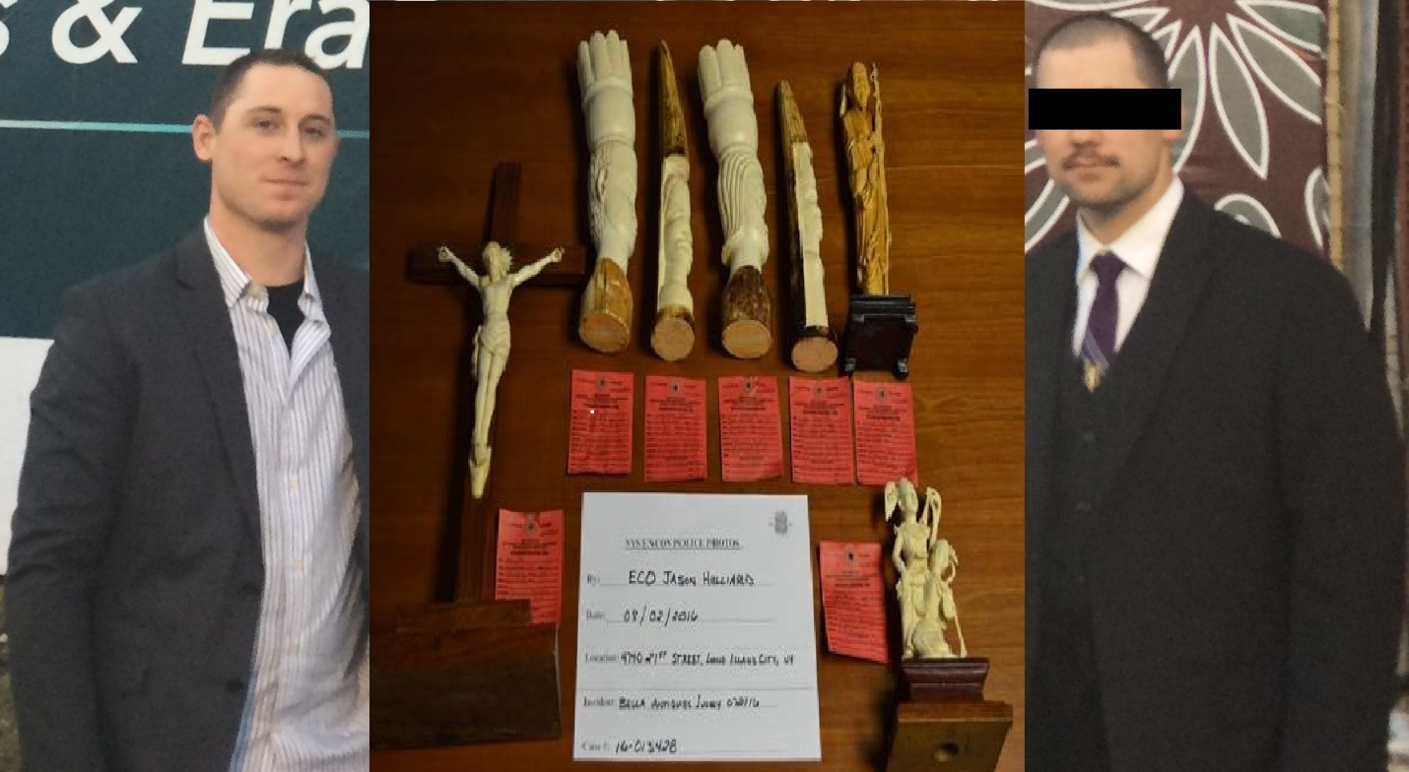
^ECO Jason Hilliard and ECI Edward Piwko with seized Elephant Ivory Items
On July 21st, 2016, during the execution of NYS DEC Bureau of Environmental Crimes Investigation (BECI) search warrants at 1050 Galleries located in New York, NY; Bella Antiques, Inc. was targeted as one of the retailers known to be offering elephant ivory items for sale. ECO Jason Hilliard, and ECO Edward Piwko were tasked with inspecting Bella Antiques, Inc. where they discovered multiple elephant ivory carvings being offered for sale. In total, seven ivory carvings, with a combined retail value of $7,000 were seized. Under the ECL, the offer for sale of an endangered species part or article without license, and the illegal commercialization of wildlife in excess of $1,500 is a class E felony.
On February 3rd, 2017 newly promoted Investigator Piwko, arrested the owner of Bella’s Antiques, Inc., Houshang Talasazan, as part of a voluntary surrender. The defendant was charged with two individual class E felonies and two corporate E felonies for the illegal commercialization of elephant ivory. Talasazan was arraigned in New York County Court where he pled guilty to two misdemeanors under the ECL and was ordered to pay a $1,000 fine. In addition, the corporation, Bella Antiques, Inc., pled guilty to two misdemeanors under the ECL and was ordered to pay a $9,000 fine. This successfully concludes a case involving the Region 2 ECOs, BECI unit, and the New York District Attorney’s Office.

