DEC Environmental Conservation Officer Highlights

ECO Actions for Late July
New York State Department of Environmental Conservation Environmental Conservation Officers (ECOs) enforce the 71 Chapters of NY Environmental Conservation Law, protecting fish and wildlife and preserving environmental quality across New York.
In 2015, the 268 ECOs based across the state responded to 25,000 calls and issued 22,000 tickets for crimes ranging from deer poaching to corporate toxic dumping to illegal mining, black market pet trade and excessive emissions violations.
"From Montauk Point to Mount Marcy, from Brooklyn to Buffalo, the ECOs who patrol our state are the first line of defense in protecting New York's environment and our natural resources, ensuring that they exist for future generations of New Yorkers," said Commissioner Basil Seggos. "They labor through long and arduous hours, often deep in our remote wildernesses or in the tight confines of our urban landscapes, and without much public fanfare. But their work centers around the most important things we do at the DEC."
Recent missions carried out by ECOs include:

Bears Cause a Scene - Herkimer County
On July 21, ECO Shana Hutton was dispatched to the village of Old Forge for a complaint of four bears - a mother and three cubs - in a tree. The tree was in the middle of the village along State Route 28, and the bears were attracting quite a crowd of on-lookers. ECO Hutton secured a safety zone around the tree and conferred with DEC wildlife staff. It was determined that the best course of action would be to wait for the bears to come down on their own. Unfortunately, as the day progressed, it became clear that there was far too much activity for the bears to make their way down the tree. Hutton, ECO Tim Worden, and a police officer from Webb rerouted vehicle and pedestrian traffic away from the tree, and after 15 minutes, the bears came down from the tree and headed off into the woods.
Bears waiting to come down from a tree in Old Forge

Operation Clear Passage - Essex and Clinton counties
Between July 11 and July 24, more than 40 ECOS participated in Operation Clear Passage on northern Lake Champlain. Clear Passage was a multi-agency operation that combined anti-terrorism and anti-radiological exercises with proactive enforcement of environmental and navigation regulations on the lake. The first phase focused on land-based water quality regulations and involved the inspection of 100 facilities with DEC permits in areas such as petroleum bulk storage, wastewater discharge and lakeside construction projects. At least 119 violations of law or permit requirements were uncovered during those inspections, including felony level offenses.
The second phase involved a three-day, on-water exercise that included staff from DEC, the New York State Division of Homeland Security and Emergency Services, the New York State Police, the New York State Park Police, the New York State Naval Militia, the New York State Intelligence Center, the New York 2nd Civil Support Team, and the Clinton County Sheriff's Office. Partners from Vermont included the Vermont State Police, Vermont Fish and Wildlife Wardens, the Vermont Urban Search and Rescue, and the Vermont Department of Health. Federal agencies participating included the U.S. Coast Guard, the U.S. Customs and Border Protection, the Domestic Nuclear Detection Office, along with the Canadian Border Patrol.
A radiation detection exercise was held involving radioactive source material being hidden on non-police vessels in the exercise area to test law enforcement's ability to detect and respond to radioactive materials in unexpected settings. Patrol activities focused on boater safety and locating marine sanitary systems that were not sealed to prevent illegal discharges of sewage into the lake. Over three days, 151 vessels were boarded and a total of 37 tickets and 70 warnings were issued for a wide range of violations. Eight of the tickets were issued for not having sealed marine sanitation devices on vessels as required by law.
Several rescues also occurred on the lake on the evening of July 23, when a powerful storm hit the area. An ECO 31-foot SAFE boat crewed by ECOs Matt Dorrett, Matt Krug, Dan Malone, and Brent Wilson was completing a patrol assignment as part of Operation Clear Passage south of the City of Plattsburg when the storm struck. Numerous vessels on the lake were making their way to safety while the crew assisted a kayaker and a swimmer traversing Willsboro Bay that were unable to get out of the path of the storm. Shortly after returning the swimmer and kayaker to safe harbor, the patrol vessel responded to a distress call from the 36-foot racing sail boat Odinn. The Odinn had lost its rudder, was unable to start its motor, and was drifting south uncontrollably near Four Brothers Island. Working through 6-foot waves, the patrol boat located the Odinn approximately three miles south of the Four Brothers Islands and two miles from the Vermont coastline. After a quick assessment of the crew of the Odinn to determine that no one was injured, the patrol boat took the Odinn under tow for the two-mile trip to a bay on the New York shore, where it was able to anchor safely to wait out the storm and assess damage to the boat.
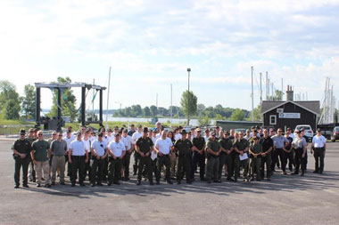
Operation Clear Passage staff on July 23 at Treadwell Bay Marina
on Lake Champlain
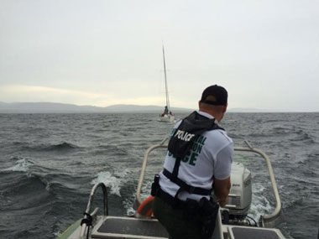
ECO Matt Dorrett adjusting the tow line to the Odinn on
Lake Champlain

Trio Caught Keeping Baby Porgies - Bronx County
On July 24, ECOs Brad Buffa and Jeannette Bastedo were checking fishermen in City Island when they observed three men round the corner of a nearby building, stop, and suspiciously back up around the corner. The officers followed them and found three large coolers full of fish. In total, the coolers contained 114 porgies and one summer flounder (fluke). Of those, 84 of the porgies were undersized, as was the fluke. Additionally, the group was over the limit by 24 porgies and none of the men possessed a recreational saltwater marine registry. The men were issued numerous summonses for the violations, which will be heard in Bronx County Criminal Court.
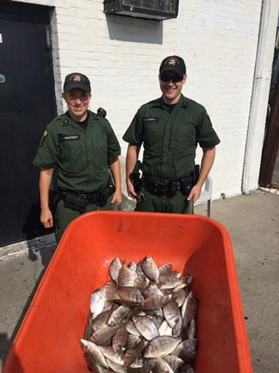
ECOs Bastedo and Buffa with illegally taken porgies

Drugged Driving Motor Vehicle Accident - Westchester County
On July 26, ECO Dustin Dainack was traveling on Route 129 - a busy two lane road in Westchester County - when he observed a woman standing in the road with her damaged car parked in a precarious position on the roadway. ECO Dainack stopped to assist her, and it soon became clear the woman was potentially under the influence of drugs, as she was having difficulty paying attention, began falling asleep, and admitted to taking prescription pills earlier that day. A second motorist was also stopped and explained that the woman nearly hit his vehicle head on and passed him between the guardrail and the passenger side of his car, striking his car as she drove by. ECO Dainack secured the impaired driver and the investigation was turned over to the Yorktown Police Department.
If you witness an environmental crime or believe a violation of environmental law occurred please call the DEC Division of Law Enforcement hotline at 1-844-DEC-ECOS (1-844-332-3267).

