DEC Environmental Conservation Officer Highlights

ECO Actions for Mid-July
New York State Department of Environmental Conservation Environmental Conservation Officers (ECOs) enforce the 71 Chapters of NY Environmental Conservation Law, protecting fish and wildlife and preserving environmental quality across New York.
In 2015, the 268 ECOs based across the state responded to 25,000 calls and issued 22,000 tickets for crimes ranging from deer poaching to corporate toxic dumping to illegal mining, black market pet trade and excessive emissions violations.
"From Montauk Point to Mount Marcy, from Brooklyn to Buffalo, the ECOs who patrol our state are the first line of defense in protecting New York's environment and our natural resources, ensuring that they exist for future generations of New Yorkers," said Commissioner Basil Seggos. "They labor through long and arduous hours, often deep in our remote wildernesses or in the tight confines of our urban landscapes, and without much public fanfare. But their work centers around the most important things we do at the DEC."
Recent missions carried out by ECOs include:
Bear Illegally Shot - Orange County
ECO Christopher Lattimer was contacted on July 12 by the town of Tuxedo Police Department regarding a bear that had been shot. ECO Lattimer responded and interviewed a homeowner who stated that the bear was going to attack his son, so he shot and killed it. After a brief investigation, ECO Lattimer determined that the son had not been in danger and was actually inside the home when the bear was shot. Officer Lattimer also found that the bear had been shot while in the road in front of the house. ECO Lattimer explained to the homeowner that he could not just shoot bears because he is afraid of them and must contact the local police and DEC to report bear issues. The homeowner was issued appearance tickets for the Illegal Taking of Protected Wildlife and for Discharging a Firearm on/across a Public Roadway. Both charges are misdemeanors, and the man will appear in the Town of Tuxedo Court.
Illegal Burning - Ulster County
On July 14, ECO Bob Hodor received a complaint of illegal burning of construction and demolition materials. Officer Hodor responded to an address on Crow Hill Road in Highland where he found burning construction and demolition debris from an old home that was being demolished. Hodor spoke with the property owner, who believed that it was legal to burn all the wood from the house. He said that he had separated out all the material he thought was illegal. The Officer explained the burning regulations and issued a ticket for the violation of the Environmental Conservation Law. The case is pending in the Town of Plattekill Court.
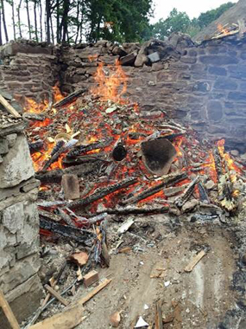
Demolition debris being burned illegally
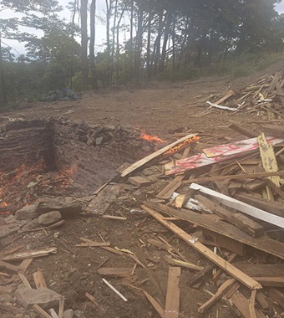
Career Day - Warren County
On July 15, Technical Sergeant Taryn Czora gave a presentation to about 60 teenage campers and camp counselors during career day at the Pack Forest DEC Camp in Warrensburg. She discussed the duties of an Environmental Conservation Officer, the importance of enforcing NY Environmental Conservation Law, how to become an ECO, and the ECO training academy program in Pulaski. A number of camp counselors have gone on to become ECOs, including Sgt. Czora, who worked at the DeBruce and Rushford DEC camps before becoming an ECO. DEC staff from the Divisions of Water, Education, Communications and Forestry also participated.
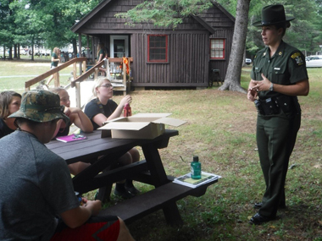
Sergeant Czora with campers at DEC's Pack Forest Camp.
Threatened Species Rescued by ECOs - Kings County
ECOs Edward Piwko and Waldemar Auguscinski responded to a call regarding a possible injured sea turtle near Coney Island in Brooklyn on July 17. The ECOs were nearby investigating illegal fishing activities and found that a Loggerhead Sea Turtle was in distress. Loggerhead Sea Turtles are listed as a "threatened species" in New York State. The ECOs determined that the turtle may have been struck by a boat and were able to rescue and transport the turtle to a wildlife rehabilitator.
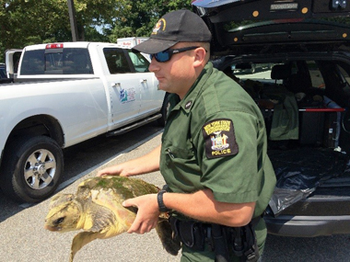
ECO carrying injured Loggerhead sea turtle.
A Jeep in the River - Rockland County
On July 18, ECO Tom Koepf was contacted to assist the Ramapo Police Department in the village of Hillburn for a motor vehicle that was stuck in the Ramapo River. The location is a popular spot for people to take their vehicles "off-roading" and on this particular day, the driver of a Jeep had some bad luck. His 2012 Jeep got stuck while trying to cross the river and as a result needed to be towed out. The vehicle suffered engine damage, and water had flooded the interior. The driver received three vehicle and traffic summonses from Ramapo PD and two summonses from ECO Koepf for Polluting Water in Contravention of Standards and Disturbing the Bed and Banks of a Protected Stream.
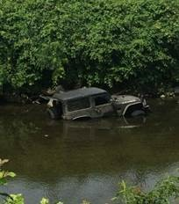
Jeep removed from the Ramapo River
in the village of Hillburn, Rockland County
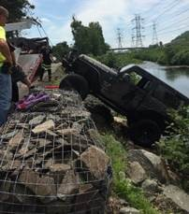
Too Many Bass - Orleans County
On July 19, ECO Paul Kroth received a call from an upset fisherman who had just left Lake Alice. The fisherman had observed a subject catch and keep at least five bass over the legal catch limit and put them in a cooler. Both the complainant and another fisherman had told this subject that he needed to release any fish that he caught over the catch limit. ECO Kroth responded to Lake Alice and contacted the suspect as he was packing up to leave. He found 22 bass in the cooler, with four of the fish being under the 12-inch size limit. The man admitted he had caught the short fish and had taken more than his legal daily limit of the fish as well. He was issued tickets for Taking Bass Over the Daily Catch Limit and Taking Bass Under the Size Limit returnable to the Carlton Town Court.
If you witness an environmental crime or believe a violation of environmental law occurred please call the DEC Division of Law Enforcement hotline at 1-844-DEC-ECOS (1-844-332-3267).

