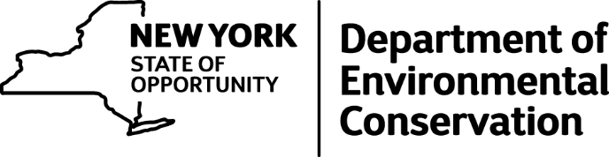

State Hunting & Trapping Education Courses Beginning

DEC Reminds Hunters and Trappers to Sign up for Education Courses and New Course Homework Requirements
The New York State Department of Environmental Conservation (DEC) and Commissioner Basil Seggos today reminded all new hunters and trappers planning to go afield this upcoming hunting and trapping season that they must first complete a mandatory hunter, bowhunter or trapper education course before they can obtain the appropriate sporting license or hunting privilege.
Hunting and trapping licenses go on sale today in New York.
"Hunting and trapping are proud traditions in New York State that continue to be safely enjoyed by hundreds of thousands of residents and visitors each year, and hunting opportunities in New York have never been better," said Commissioner Seggos. "Our Sportsman Education Program is effective in producing safe, ethical hunters and we are grateful to the volunteer instructors that serve as the backbone to deliver our program. I encourage all prospective hunters to sign-up early for one of the hundreds of courses offered all across New York."
DEC works closely with thousands of dedicated DEC-certified instructors statewide to provide these training courses free of charge. Courses are offered for Hunter Education, Bowhunter Education, Trapper Education and Waterfowl Identification. However, courses fill up quickly, so those interested should sign up for a course soon to be sure they complete it before going afield this fall.
With the DEC on-line registration system, viewing a list of all available hunter and trapper education courses with the student's proximity to course locations can be easily done. Students can register from any device - smartphone, tablet or computer - 24 hours a day, seven days a week.
Education courses are added continuously throughout the year, so be sure to check the on-line system frequently to find a course near you. To locate a nearby hunter or trapper education course, visit DEC's website or contact a local DEC office for assistance.
New course homework requirements instituted this year
All hunter education and trapper education courses now require students to review course materials and complete a homework sheet prior to attending the classroom and field sessions. The new homework portion of the course provides an introduction to the subject and enhances the students' understanding of the course material. Proof of the completed homework is required in order to attend the classroom and field portions of the course. Students should register for the course well in advance of the classroom and field date(s) in order to allow time to complete the homework requirement, which takes about three hours. All courses also require successful completion of an in-person field day to earn certification for the course.
Access to the homework materials and online homework options can be found on DEC's website or follow the guidelines listed in the various course announcements when you register for a particular class. Actual course manuals and homework sheets are always available from DEC wildlife offices and sportsman education instructors.
Education courses produce results in hunter safety
New York's hunter education courses are highly effective in fostering safe hunters. Approximately 500,000 licensed hunters spend an estimated 10 to 15 million days afield each year. Reports on the number of hunting-related shooting incidents indicate that 2015 had the third lowest number on record in New York. The 2015 hunting season yielded the first year without a hunting-related shooting fatality since the 1950s.
These low numbers are achieved through training and the regulations governing hunting activities in New York State. DEC's Sportsman Education Program is designed to teach and promote safe and effective hunting principles, practices and strategies. The program has been extremely successful over its 66 years of existence. For details on last year's hunter safety record can be found on DEC's website.

