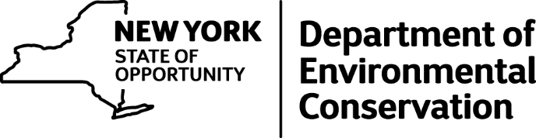

DEC Confiscates More Than 1,100 Pounds of Illegal Lobsters from Price Chopper
The New York State Department of Environmental Conservation (DEC) Environmental Conservation Officers (ECOs) seized more than 1,100 pounds of undersized lobsters from Price Chopper in three different inspections over the last four months, the agency announced today.
The case was sparked in March when ECOs in Region 7 found short lobsters at two Price Chopper stores in Binghamton. In May, ECOs executed random checks at Price Chopper stores across the state and found similar results.
The distribution center for Price Chopper is located in Schenectady, and Region 4 ECOs performed a routine inspection at the facility Tuesday, measuring 297 cases of lobsters. ECOs determined that 820 lobsters (approximately 15 percent of the inventory) were under the legal size limit set by the state's Environmental Conservation Law (ECL). At least 105 undersized lobsters have been seized at the other stores, with the total seizure valued at more than $7,000.
The law requires lobsters taken, possessed, bought, sold, imported and exported in New York measure between 3 and 3/8-inches and 5 and 1/4-inches from the eye socket to the end of the body shell.
Size restrictions have been placed on lobsters, a valuable natural resource, to protect the fishing stock. Over the last several decades, American lobsters have experienced periods of population declines due to overfishing, and allowing lobsters to grow and reach maturity bolsters the stock.
Price Chopper faces fines for violations of ECL provisions of the Fish and Wildlife Law of up to $100 for every shellfish involved. DEC will attempt to negotiate a settlement with Price Chopper in the coming weeks.
The undersized lobsters were seized and donated to the Regional Food Bank of Northeastern New York in Latham Wednesday.
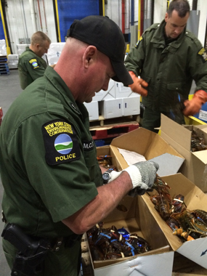
ECO with box filled with undersized lobsters.
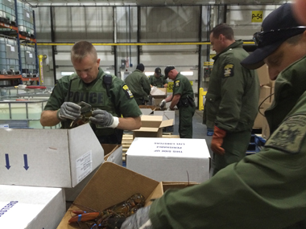
ECOs inspecting lobsters seized from Price Chopper.

