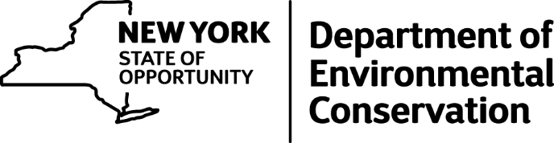

DEC Announces New Deer and Bear Hunting Regulations
The New York State Department of Environmental Conservation (DEC) today unveiled new regulations concerning deer and bear hunting, DEC Commissioner Basil Seggos announced today.
These regulations increase opportunities for junior hunters to take bears, rescind an antlerless-only rule from 2015 in portions of southeastern New York and the Lake Plains, reduce antlerless harvests in two management units in the western Adirondacks, and clarify when special season tags may be used by bow and muzzleloader hunters.
"We rely on hunters to help us meet our science-based population management goals, and these new regulations will help us explore alternative season structures that will advance improved population management," said Commissioner Seggos. "The youth hunt has been very popular with families across the state, and we're pleased to offer this expanded opportunity for junior hunters."
The new bear hunting regulation now includes the taking of bears in the youth firearms hunt over Columbus Day weekend that was previously a deer-only event. The 2015 regulation that prohibited harvest of antlered deer during portions of the bow and muzzleloader seasons in Wildlife Management Units (WMUs) 1C, 3M, 3S, 4J, 8A, 8C, 8F, 8G, 8H, 8N, 9A, and 9F has been rescinded, allowing the take of both antlered and antlerless deer during the entire bow and muzzleloader seasons in these units.
In these WMUs, deer populations are above desired levels, and the antlerless-only rule was implemented in 2015 as part of a multi-phase process to increase antlerless harvest. However, reported harvest of female deer did not differ substantially between the WMUs with the antlerless-only periods and nearby WMUs without the rule, nor did the antlerless-only periods increase reported female take as desired.
In contrast, deer populations in WMUs 6F and 6J have been declining, so harvest of antlerless deer is now prohibited during the early muzzleloader season in these units. Winter weather conditions are a primary driver of deer abundance in the northern part of the state, and the winters of 2013 and 2014 were especially harsh. Coupled with mild conditions this past winter, reducing the harvest of antlerless deer should prevent further population decline and stimulate growth. The DEC expects this change to be temporary.
The final regulatory change is simply a technical correction to clarify that hunters who purchase both the bow and muzzleloader license privileges may use the Bow/Muzzleloader either-sex and Bow/Muzzleloader antlerless-only deer tags in either season or both in one of the seasons with the appropriate implement. This has always been DEC's intent, but ambiguity in the previous wording of the regulation could have led to confusion. Hunters who purchase just one of the special season privileges are still only allowed to use the Bow/Muzzleloader tag during that particular special season.
Under the 2016-17 budget, Governor Cuomo's NY Open for Fishing and Hunting Initiative provides $3 million for State land access projects and $4 million for hunting and fishing infrastructure. The 2015-16 budget also created a new capital account, which, along with federal Pittman-Robertson funds, will be used to manage, protect and restore fish and wildlife habitat and will improve and develop public access for fish and wildlife-related recreation. This year's commitment builds on the previous $6 million in funding for 50 new projects to provide access to approximately 380,000 acres of existing State lands for recreation, including boat launches, bird-watching areas, trails and hunting blinds, and $8 million for upgrades and improvements to fish hatcheries statewide.

