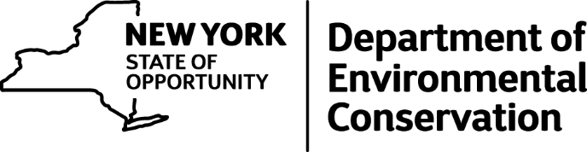

DEC Environmental Conservation Officer Highlights

ECO Actions for Early July
New York State Department of Environmental Conservation Environmental Conservation Officers (ECOs) enforce the 71 Chapters of NY Environmental Conservation Law, protecting fish and wildlife and preserving environmental quality across New York.
In 2015, the 268 ECOs based across the state responded to 25,000 calls and issued 22,000 tickets for crimes ranging from deer poaching to corporate toxic dumping to illegal mining, black market pet trade and excessive emissions violations.
"From Montauk Point to Mount Marcy, from Brooklyn to Buffalo, the ECOs who patrol our state are the first line of defense in protecting New York's environment and our natural resources, ensuring that they exist for future generations of New Yorkers," said Commissioner Basil Seggos. "They labor through long and arduous hours, often deep in our remote wildernesses or in the tight confines of our urban landscapes, and without much public fanfare. But their work centers around the most important things we do at the DEC."
Recent missions carried out by ECOs include:

Shooting at a Portable Toilet - Chemung County
On July 3, Lieutenant Matt Lochner and ECO John Lifrieri were on plain clothes patrol in an unmarked vehicle at the Minier's Field Boat Launch in the town of Big Flats. The officers observed two male individuals who were standing outside of their parked car. One of the men appeared to be drinking alcohol. Upon talking to the individuals, it became quite evident that both men had been drinking alcohol, and ECO Lifrieri observed a shotgun in the back seat of their vehicle. The officers found that it was loaded. Lt. Lochner later found spent shell casings in between the vehicle and a nearby portable toilet, and ECO Lifrieri matched the spent casings to the live rounds in the shotgun. Three shotgun slug holes were also spotted in the portable toilet. Both suspects admitted to shooting the "port-a-potty" and were arrested for violations of Penal Law and Possession of a Loaded Firearm in a Motor Vehicle. The driver also had a revoked driver's license and admitted to driving to Minier's Field, resulting in him being charged with Vehicle and Traffic Law violations as well. Both cases will be heard in the Town of Big Flats Court.
Manure Fire - Cayuga County
On July 5, ECO Don Damrath received multiple calls complaining of smells and smoke emanating from a burning pile of horse manure in the town of Throop. ECO Damrath responded and found that horse stable owners had been storing the manure in large piles and they spontaneously combusted in the excessive heat and dry conditions. ECO Damrath was told that the piles spontaneously ignite frequently, but prevailing winds normally blow the smell of the smoldering manure away from the stables. This time, the winds were carrying the smoke into neighbors' windows, and the flames spread dangerously close to a valley full of dry vegetation and dead trees. It took three local fire departments more than two hours to extinguish the burning manure. The stable owners were advised to take measures to mitigate the combustion problem immediately.
Illegal Shark Parts - Suffolk County
On July 6, ECOs Jeff Hull, Kevin Holzle and Ron Gross performed fish market inspections throughout the towns of Smithtown and Islip. They were finishing up their day when one of the officers observed a large styrofoam container with shellfish stacked on top. Inspection of the container led to the discovery of a thresher shark tail, a mako shark tail and multiple shark fins. The owner was quick to make excuses for why he had the shark fins in his shop. He was issued a summons for Illegal Possession of Shark Fins without the Carcass.
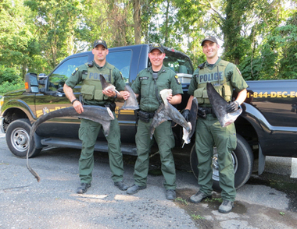
ECOs Hull, Hozle and Gross with illegally possessed shark fins.

Air Quality Enforcement - Queens County
On July 6, Region 2 Division of Law Enforcement conducted an Air Quality Enforcement Operation on Rockaway Boulevard in Jamaica Queens, a heavily traveled truck corridor. An inspection site was established on the side of the road, and ECOs conducted random inspections to ensure truck emission control devices were working properly. Approximately 30 vehicles were inspected, resulting in summonses being issued for five air quality violations and two additional violations. Officers participating in the detail were Lt. Michael Buckley, ECO John Gates, ECO Bradley Buffa, ECO Wesley Leubner, ECO Jeannette Bastedo, ECO Waldemar Auguscinski, ECO Edward Piwko, ECO Kevin Cummings and ECO Paul Pasciak. Captain Francisco Lopez was also present to supervise the activity.
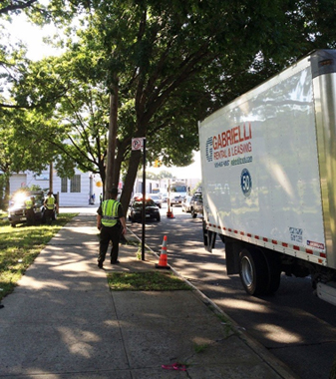
Air quality enforcement in Queens
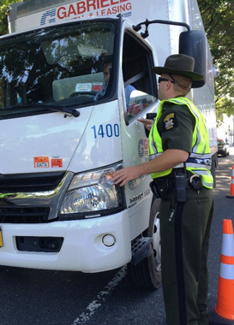

Joint Enforcement For Sea Scallops - Suffolk County
On July 6, ECOs Jordan Doroski and Landon Simmons were patrolling the fish docks at Shinnecock Inlet from an unmarked vehicle. As the Officers watched vessels returning to the inlet, a commercial sea scallop boat caught their attention when four crew members climbed onto the cabin roof and appeared to be looking closely around the area. The ECOs also observed a suspicious vehicle in the parking lot, occupied by a middle aged man on his cell phone. Officers have encountered "scouts" being used in the Shinnecock Inlet area in the past to alert fishing vessels with illegal harvests to the presence of law enforcement. ECOs Doroski and Simmons determined that particular boat would be appropriate to be inspected for compliance with federal sea scallop regulations. The ECOs met the vessel at the dock. The captain agreed to offload the entire catch while the ECOs called National Marine Fisheries Service Special Agent Todd Smith to assist in counting the catch. The total catch was 109 bushels of whole sea scallops and one small bag of sea scallop meat, putting the vessel more than 35 bushels over federal regulation limits. The case was turned over to Special Agent Smith for further investigation and enforcement.
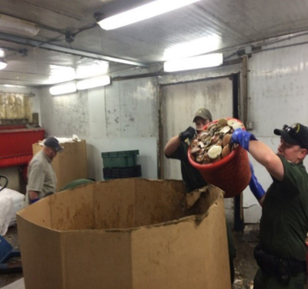
ECOs counting the illegal scallop catch
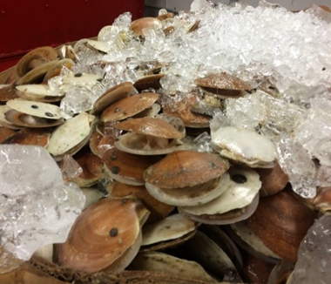
Some of the illegal catch

Scotts Lawncare Settles Pesticide Violations Case - Erie County
On July 7, Scotts Lawncare entered into a civil settlement with the DEC to pay a $20,000 penalty to settle violations that stemmed from a pesticide discharge. The initial incident occurred on March 25, when ECO Chuck Wilson responded to a complaint of trucks leaking fluids at a facility in the town of Amherst. A complainant observed two Scotts Lawncare trucks leaking profusely and an employee washing an unknown yellow/orange liquid into storm drains that discharge into Ellicott Creek. Officer Wilson responded and located the leaking vehicles. After a lengthy investigation in conjunction with DEC's Division of Pesticides, the company was charged with various pesticide regulation and water quality violations.
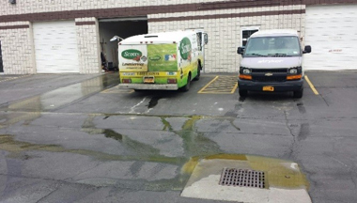
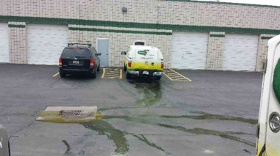

Deer Freed After Getting Stuck in Fence - Richmond County
On July 8, ECO Edward Piwko responded to a retirement home on Staten Island to assist with a complaint of a young female deer stuck in a fence behind the property. ECO Piwko was assisted by members of the NYPD Emergency Services Unit. NYPD held down the deer with catch poles so ECO Piwko could restrain the deer. Once the deer was restrained, so as not to harm itself or the officers, it was freed from the fence. The deer ran off into the woods seemingly unharmed.
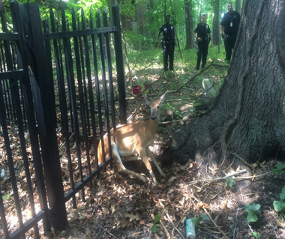
Deer stuck in a fence on Staten Island.

Over the Limit of Trout on the Boquet River - Essex County
On the afternoon of July 8, DEC's Ray Brook dispatch office received a complaint of an individual taking over the daily limit of trout on the Boquet River in Elizabethtown. The fisherman was described as being accompanied by two dogs, and the complainant was able to obtain a license plate number of the vehicle being operated by the fisherman. ECO Jeff Hovey located the vehicle at a camp in the town of Keene a short time later. ECO Hovey found that the fisherman was in possession of 12 brook trout and one brown trout that the fisherman admitted he had caught earlier in the day on the Boquet River, more than double the daily catch limit of five fish. ECO Hovey issued the fisherman a ticket for Taking Over the Daily Limit of Trout.
If you witness an environmental crime or believe a violation of environmental law occurred please call the DEC Division of Law Enforcement hotline at 1-844-DEC-ECOS (1-844-332-3267).

