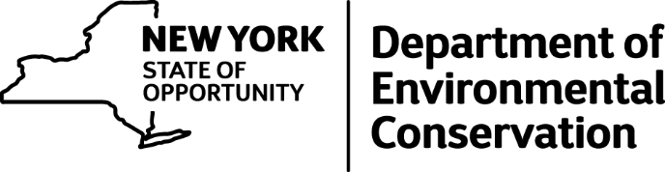

DEC Seeks Participants for Summer Turkey Survey
New York State Department of Environmental Conservation (DEC) and Commissioner Basil Seggos are encouraging New Yorkers to participate in a survey for wild turkeys this summer.
"Citizen science" efforts such as this provide wildlife managers with invaluable data and give people the opportunity to partner with DEC to help monitor New York's wildlife resources. Participants can record observations of turkeys while exploring the forests and fields around their home or driving through the State's beautiful landscapes this summer.
"Having up-to-date population data is essential to ensuring effective management decisions and possessing a better understanding of how wild turkey populations fluctuate in New York," Commissioner Seggos said. "DEC encourages all New Yorkers to participate in this valuable survey and help collect this vital information on turkey populations and survival rates."
Since 1996, DEC has conducted the Summer Wild Turkey Sighting Survey to estimate the number of wild turkey poults (young of the year) per hen statewide. Weather, predation, and habitat conditions during the breeding and brood-rearing seasons can all significantly impact nest success, hen survival, and poult survival. This index allows us to gauge reproductive success and predict fall harvest potential.
During the month of August, survey participants record the sex and age composition of all flocks of wild turkeys observed during normal travel. If you would like to participate, you can download a Summer Wild Turkey Sighting Survey form from the DEC website. Detailed instructions can be found with the data sheet. Survey cards can also be obtained by contacting your regional DEC office, by calling (518) 402-8886, or by e-mailing wildlife@dec.ny.gov (please type "Turkey Survey" in the subject line). You can also submit your observations on-line.

