Third annual Mariaville Lake Kids Ice Fishing Derby

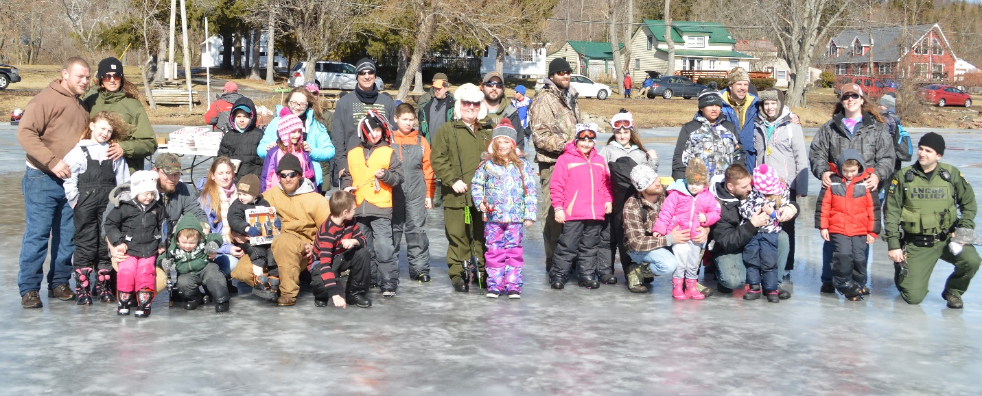

February 20th 2016 marked the 3rd year that local sponsors, the Schenectady County Conservation Council (SCCC) and the NY Conservation Officers Association (NYCOA) hosted a kids fishing derby on Mariaville Lake in Schenectady County.
The event kicked off at 8:00am and concluded at 12:00pm. A total of 33 children and their parent(s) showed up throughout the tournament to participate. The SCCC provided each child with a free tip-up that they could use and keep as well as first class power auger service. ECO’s Jason DeAngelis, Chris Valenty, Brian Willson, Tim Card and Lt. Thomas Harrington as well as members of the SCCC were on hand to assist kids and parents. David Pirrone, owner of the Mariaville Lakeside Store also sponsored the event. He graciously provided all of the free bait and pizza for everyone in attendance throughout and at the end of the tournament. Prizes of $40.00, $30.00 and $20.00 for the largest fish in each of two categories (pickerel and perch). The SCCC and NYCOA also provided extra prizes which were used for out of category fish and drawing prizes. Local business the “Wiggly Worm” also contributed gift certificates.
More fish were reeled in this year than any other; about forty in total. Top fish caught included a 23 inch pickerel a 21 inch pickerel and a 20 inch pickerel, several 11 inch perch and two 17 inch largemouth bass as well as crappie were also landed. The event was a big success thanks to everyone who contributed. Thank you.

