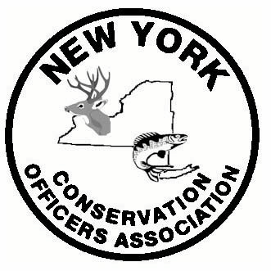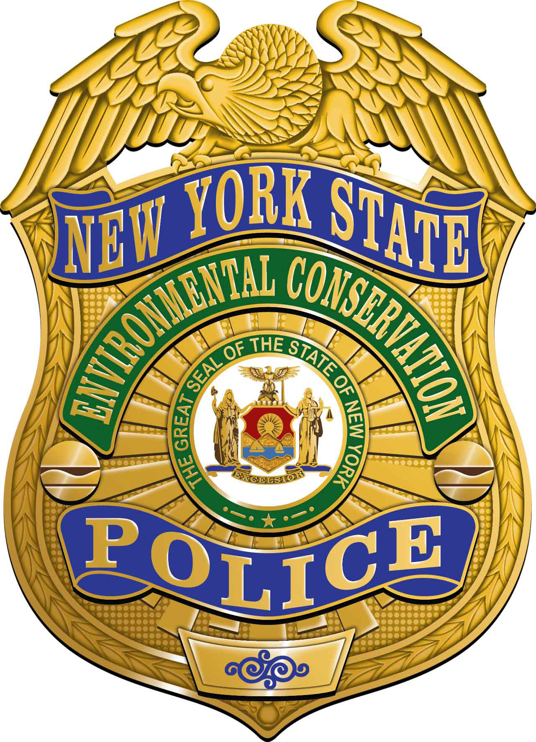 2016 NYCOA Convention
August 8th & 9th
Cortland-Ithaca, NY

Agenda

MONDAY AUGUST 8th

10:00 am – GOLF AT WILLOWBROOK GOLF CLUB, 3267 NYS Route 215 Cortland, NY 13045 $40/person includes cart, lunch, and prizes for long drive and closest to the pin.
http://willowbrookcortland.com/

ALL DAY:
CASCADES INDOOR WATERPARK AT GREEK PEAK - Discounted rate of $17/person for any attendees, whether or not they are lodging at Greek Peak. Mention NYCOA when purchasing passes at the waterpark.
http://cascadesindoorwaterpark.com/

WATERFALLS SPA AT HOPE LAKE LODGE – 10% discount on all services. Call 866-948-3320 to book. Mention NYCOA.
http://waterfalls-spa.com/

GREEK PEAK ADVENTURE CENTER – Zip lines, Mountain Coaster, Euro Bungee, Aerial Challenge Course, Bounce House, Kiddie Climbing Wall and more! Prices vary depending on group size. We need minimum of 20 people for discounted rate so sign up early!
http://theoutdooradventurecenter.com/

4:00 pm - BBQ BUFFET PICNIC & WARDEN GAMES (details to follow) at Hope Lake Lodge on Hope Lake. Includes pulled pork, Hoffman Hot Dogs, Sirloin Hamburgers, and refreshments. $30 for adults, $20 for kids under 10, free for kids under 3.

TUESDAY AUGUST 9th

9:00 am - NYCOA Business Meeting at Hope Lake Lodge (room TBA) – Continental Breakfast provided by NYCOA

12:00 – 4:00 pm – WINERY TOUR TBA on chartered bus if enough people are interested. Sign up on registration form so we can get a head count.

ALL DAY:
CASCADES INDOOR WATERPARK AT GREEK PEAK - Discounted rate of $17/person for any attendees, whether or not they are lodging at Greek Peak. Mention NYCOA when purchasing passes at the waterpark.
http://cascadesindoorwaterpark.com/

WATERFALLS SPA AT HOPE LAKE LODGE – 10% discount on all services. Call 866-948-3320 to book. Mention NYCOA.
http://waterfalls-spa.com/

GREEK PEAK ADVENTURE CENTER – Zip lines, Mountain Coaster, Euro Bungee, Aerial Challenge Course, Bounce House, Kiddie Climbing Wall and more! Prices vary depending on group size. We need minimum of 20 people for discounted rate so sign up early!
http://theoutdooradventurecenter.com/

THE FINGER LAKES TASTING ROOM - Wine, Beer, & Spirits
http://fltroom.com/index.html
Phone: 607-662-4661
Email: FLTRcontact@gmail.com

6:00pm-10:00 pm – DINNER BANQUET AND AUCTION on the Trax Pub & Lounge Outdoor Deck overlooking Greek Peak (weather permitting). If inclement weather the banquet and auction will be held in The Acropolis Ballroom with outdoor veranda overlooking Greek Peak. Pizza party available for kids ages 3-11 during the banquet in a separate room.

Meals

BBQ Picnic - $30 per person, $20 for kids under 10, Free for kids under 3.

Banquet - $55 per person includes 2-hour Open Bar, Hors D’oeuvre platter, Salad, Rolls & Butter, Roast Beef, Baked Haddock, Potato Medley, Steamed Green Beans, Strawberry Shortcake, Coffee/Tea/Soda

Pizza party- $20 per person for kids under 12. Held in a separate room adjacent to the banquet. Includes Salad, Cheese or Pepperoni Pizza, Assorted soft drinks and water, Potato Chips and Brownies.

ACCOMODATIONS

NYCOA has reserved blocks of rooms at the following hotels. We suggest you book your room as early as possible (but no later than June 15) due to the busy summer season. Mention NYCOA when you make your reservation.

GREEK PEAK MOUNTAIN RESORT – 2177 Clute Road, Cortland, NY 13045
(800) 955-2754.
$149/night - 2 queen beds/full kitchens available. UNDER NYCOA. Suites that sleep 6-10 people available for higher rates.
http://hopelakelodge.com/

HOTEL ITHACA (Downtown Ithaca)
222 South Cayuga Street • Ithaca, New York 14850
(607) 288-2096
$139 -159/night. Under NYCOA
www.Thehotelithaca.com

RAMADA INN ITHACA AIRPORT
2310 N. Triphammer Rd.
Ithaca, NY 14850
(607) 257-3100
$129.95/night includes breakfast. Under NYCOA.
http://www.ramada.com/Ramada/control/Booking/property_info?propertyId=05091&amp;cid=range_google_regional-Ramada

SUPER 8
400 S. Meadow St
Ithaca, NY 14850
(607) 273-8088
$115/night. Under NYCOA
http://www.super8.com/

CAMPING

TAUGHANNOCK FALLS STATE PARK
BUTTERMILK FALLS STATE PARK
ROBERT H.TREMAN STATE PARK
For information contact:
http://parks.ny.gov/
1-800-456-2267
For reservations contact:
http://www.reserveamerica.com
1-800-456-CAMP or http://newyorkstateparks.reserveamerica.com

Spruce Row Campground & RV Park
2271 Kraft Road, Ithaca
607-387-9225
For rates, dates and reservations: sprucerow.com

Another great resource for information:
http://www.visitithaca.com/lodging/camping.html

ATTRACTIONS/OTHER ACTIVITIES

FISHING
Hope Lake
http://hopelakelodge.com/amenities/hope-lake-beach
Fishing poles and bait can be purchased and fishing boats, paddle boats and canoes are available to rent at the lifeguard and first aid headquarters.

Blue Moon Sport Fishing Charters on Cayuga Lake & Lake Ontario
315-283-8878
http://bluemoon.lakeontariounited.com/

Trout Fishing streams in Central New York
http://www.dec.ny.gov/outdoor/44869.html

HUNTING
Finger Lakes Exotics Farm - Private Game Ranch & Lodge
Mention NYCOA & Don Damrath. For more information or to
make a reservation...
Call: Kasey or Juli at (315) 496-2256
http://fingerlakesexoticfarm.com/index.html

http://ithacaboattours.com
416 Old Taughannock Blvd., Ithaca, NY
607-697-0166
* Early-Bird Picnic Cruise, 12:30-2:30pm, Fridays & Mondays: Bring along a picnic and beverages of your choice, and enjoy a relaxing, fully narrated tour of southern Cayuga Lake. We now offer a delicious box-lunch option from Green Star Market, for just $10. Place an order from our oinline menu when you make your reservation, and your choice of locally-produced sandwiches and salads will be waiting for you on the boat!
* Afternoon Eco-Cruise, 4:00-6:00pm, Thursdays through Mondays: This fully narrated cruise emphasizes the natural history of the Finger Lakes, and features brief demonstrations by high school interns working with the Cayuga Lake Floating Classroom. Opportunities to participate in lake-study activities make this a fascinating, interactive option for the whole family.

CANOE/KAYAK RENTALS

http://www.puddledockers.com/
704 W Buffalo St., Ithaca, NY 14850 - (607) 273-0096

http://paddlenmore.com/
Taughannock Falls State Park

MUSEUMS

Museum of the Earth
http://www.priweb.org/

The Sciencenter
http://www.sciencenter.org/

COLLEGES

Cornell University
www.cornell.edu

Ithaca University
http://www.ithaca.edu/

SUNY Cortland

REGISTRATION FORM
Registration Deadline June 15th
2016 NYCOA Convention
August 8 & 9
Cortland - Ithaca, NY

Attendees Names: ___________________________________________________
Address: __________________________________________
___________________________________________________
Phone Number: _________________
Email ______________________________________

Important Note: There is a $10.00 registration fee for each family member (over 10yrs. old) attending the convention. This fee will help cover refreshments for all events, a HOSPITALITY ROOM located in the Hope Lake Lodge, and other miscellaneous items.

Registration Fee (over 10 yrs. old) ___ x $10 = ____

BBQ ___ x $30 = ____
Under 10 ___ x $20 = ____
Under 3 Free

Banquet ___ x $55 = ____
Kids 3 and up attending pizza party ___ x $25 = ____

Total = ______

Wine tour head count - # of people = _______

Golf tournament head count - # of players = _______

Warden Games head count - # of people = _______

Name for Retiree Shoot (TBA – more info to come) – Wednesday August 10 at Finger Lakes Exotics - _________________________

DON’T FORGET A BOTTLE OF BOOZE OR WINE FOR THE WHEELBARROW OF CHEER RAFFLE!

Please return this form along with a check payable to NYCOA by June 15, 2016 to:

Don Damrath
1133 Willowdale Rd.
Skaneateles, NY 13152

Thank you. We look forward to seeing you and your family! It’s going to be a great time!

Any questions please call or email Don Damrath 716-341-6950

