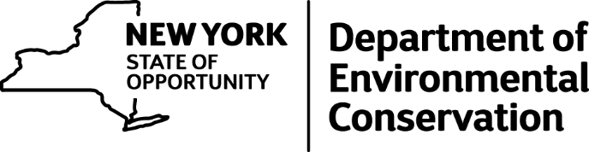

For Immediate Release: 04/11/16
Contact: Benning DeLaMater | (518) 402-8000
Press Office | PressOffice@dec.ny.gov

DEC Announces Law Enforcement Awards For Distinguished Service
Environmental Conservation Officers and other law enforcement professionals recognized for outstanding service to protect the environment and public health and safety

The New York State Department of Environmental Conservation announced the awards for distinguished actions of dozens of its service members and other law enforcement officials from across the state. DEC’s Division of Law Enforcement Police Awards are presented every three years and recognize the courageous acts and distinguished service of Environmental Conservation Officers (ECOs) and several State Troopers, Sheriff’s Deputies, Assistant District Attorneys and elected officials who helped to protect the environment and uphold Environmental Conservation Law.
“DEC’s Environmental Conservation Officers are the state’s first line of defense in protecting the environment and safeguarding natural resources, and I am honored to present these important awards and recognize the incredible efforts of our law enforcement personnel,” said DEC Acting Commissioner Basil Seggos. “From catching poachers to holding polluters accountable, our ECOs and law enforcement professionals work tirelessly, and often in remote locations, to uphold the state’s environmental conservation laws and protect public health and safety, and I applaud their selfless service to the State of New York.”
This year’s Awards were presented to 27 ECOs and other law enforcement professionals for a range of activities, including:
- saving the life of a 2-year-old boy who had stopped breathing;
- saving a suicidal man’s life;
- uncovering illegal corporate toxic dumping;
- busting a shark fin trading operation;
- halting illegal deer poaching;
- the apprehension of an armed subject in the woods;
- busting illegal marine fishing operations; and
- the formation of the Division’s Naloxone program
In addition to the awards, three new members of the DLE K-9 unit were also sworn into service.

(MORE)
-2-

The mission of the ECOs, who were first appointed in 1880 is “to protect and enhance the environment and natural resources of the State of New York while also protecting the health and safety of its people through the enforcement of Environmental Conservation and related laws and public education." Currently there are 268 ECOs who patrol across the state. In 2015, ECOs responded to more than 25,000 calls and issued more than 22,000 tickets in enforcing the Environmental Conservation Law, protecting fish and wildlife and preserving environmental quality across New York.
To view a detailed list of award winners and the citations, visit http://www.dec.ny.gov/docs/legal_protection_pdf/2016ecoawards.pdf.
###
Connect with DEC on Facebook, Twitter and YouTube

