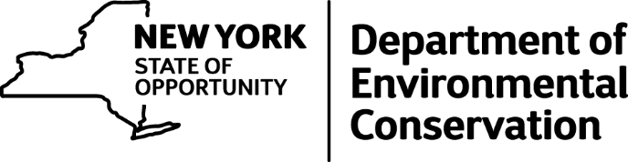

NYS Department of Environmental Conservation added 3 new photos.
Environmental Conservation Officer Nathan VerHague seized this Cuvier's dwarf caiman from an individual in the City of Niagara Falls on Thursday, April 21st. The owner was issued an appearance ticket for city court for unlawfully possessing a wild animal. The caiman was transported to a facility in Pennsylvania where it will be cared for by a licensed professional.

