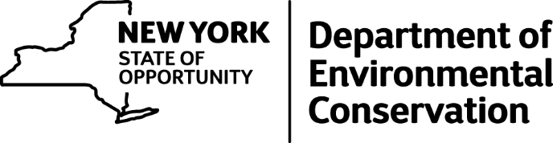
For Release: Tuesday, April 12, 2016

Cooperation Across State Border Leads to Arrest and Charges

Pennsylvania Man to Pay More Than $2,000 in Fines and Serve a Month of Work Weekends at the Broome County Jail for Hunting Violations in New York
A Pennsylvania man was convicted of several offenses of New York State Fish and Wildlife Law after he was found to have illegally harvested a white-tailed deer as a non-resident, the Department of Environmental Conservation announced today.
NYS Environmental Conservation Officers (ECOs) with the help of Pennsylvania Wildlife Conservation Officers (WCOs) charged Donald J. Bray of Lake Ariel, Pennsylvania, with a bevy of offenses after an extensive investigation found that Bray had harvested a white-tailed deer in New York in October 2015 and had transported the deer back to Pennsylvania.
"This case is a great example of what can be accomplished when we collaborate with our fellow officers across the border, and I applaud our ECOs and the Pennsylvania WCOs for working together on this important case," said DEC Acting Commissioner Basil Seggos. "Our science-based deer management policies are in place to maintain a healthy deer herd and allow hunters ample opportunities to enjoy the sport. When hunters don't play by the rules, we take it seriously."
Through the joint investigation, ECOs and WCOs determined that Bray had purchased a resident NYS big game license on Oct. 25, 2015 but claimed on the application he lived in the town of Kirkwood, Broome County. However, his permanent, year-round residence is in Pennsylvania, and he only owned a seasonal hunting camp in New York, making him ineligible for an in-state big game license. Bray admitted taking an eight-point buck and utilizing his regular season antlered tag, not the appropriate archery tag. He also admitted he purchased his unlawful resident license 15 days after the harvest of the deer. Bray was also found to be hunting with a center-fire rifle in a shotgun only area of Broome County.
Bray told the officers that the meat from the deer was at a bar he owned in Pennsylvania, but was adamant that he did not possess the rack of the deer. However, through the perseverance of Pennsylvania WCOs, they located and confiscated the rack from a taxidermist shop near the subject's home, and Bray quickly admitted to lying.
Bray was charged with: unlawful taking of a whitetail deer, making a false statement when applying for a NYS resident license (while being a Pennsylvania resident), two charges of hunting big game without a valid hunting license, hunting with a center-fire rifle in a shotgun only area, failing to wear a back-tag, and failing to comply with the mandatory tagging requirements for deer.
Bray agreed to a settlement in Town of Kirkwood Court and was ordered to pay $2,000 in fines and a $75 surcharge. He was also sentenced to a month of work weekends at the Broome County Jail.

