In an event organized by Environmental Conservation Officer James Davey with support from the NY Conservation Officers’ Association and Cathy Burke with support from the Columbia County Sportsmen’s Federation, six young men and women got an opportunity to hunt turkeys during the state’s Youth Turkey Season on April 23rd and 24th. Eight youths went out in the field at various locations throughout the County. Four successfully harvested birds.

The Craryville Rod & Gun Club hosted a Safety Talk for the Turkey Hunt on Saturday, April 16. Youth and mentors came together to discuss the hunt, important safety issues, and patterned the shotguns that were used. The Environmental Conservation Officers fund generously donated $250 that was used to purchase supplies for the young hunters. Shooters Supply of Valatie, Gander Mountain, and Kaatskill Mountain Calls all made donations to the program.

Mentors for the hunt included: ECO James Davey, ECO Lt. Liza Bobseine, Nancy Davey, Kathy Burke, Jim Bertram, Richard Odell, Jim Bashford, Ray Shields, John Bartholomew, and Ron Banks.

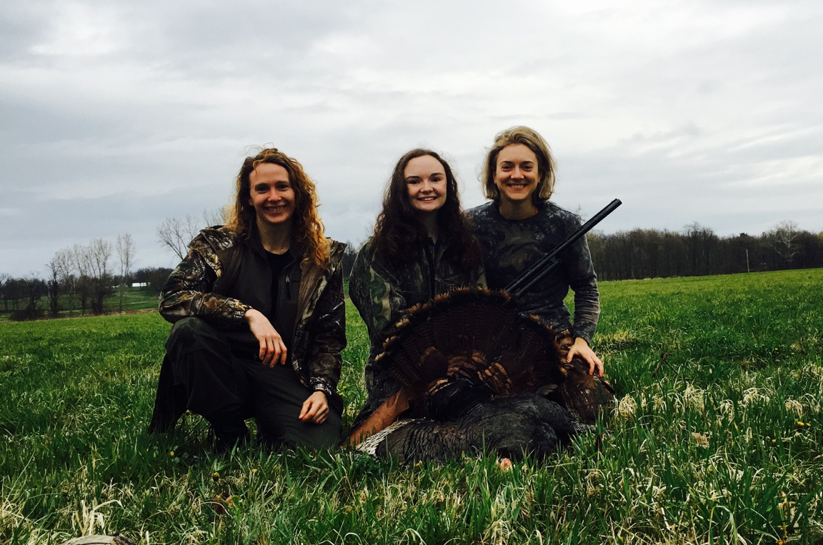
Kalista Kopec took the first turkey of the weekend while be mentored by ECO Lt. Liza Bobseine(L) and Nancy Davey (R).
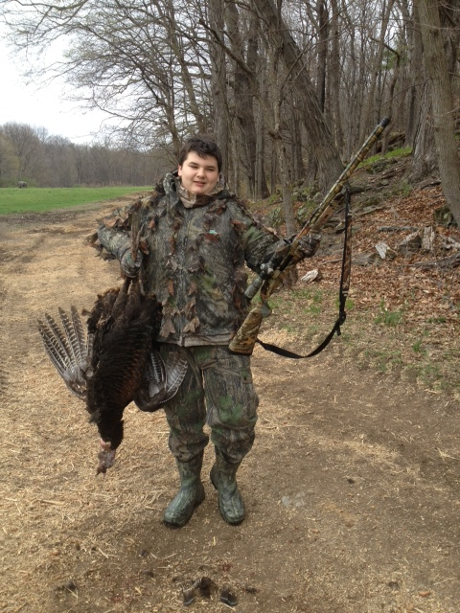
Keith Sitzer shows off his successful day

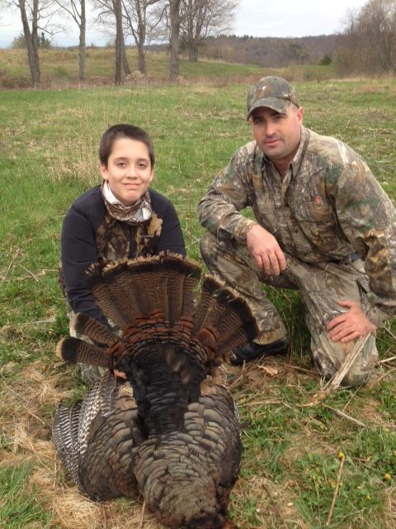
Ethan Garbarini and ECO James Davey

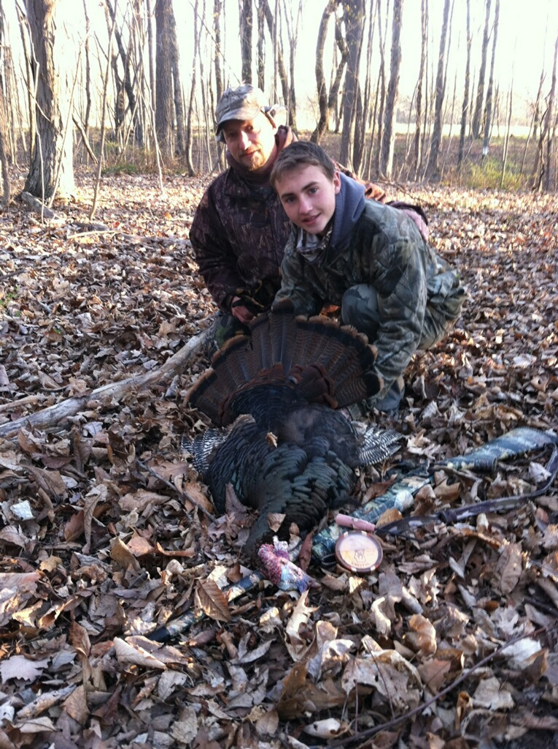

Gannon Krein and his dad.

