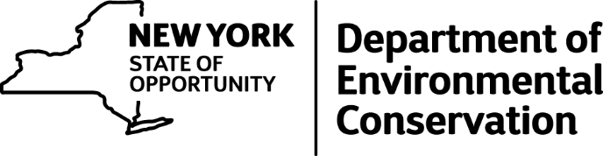

DEC ECOs Uncover Illegal Venison Operation
A two-year investigation by New York State Department of Environmental Conservation (DEC) Environmental Conservation Officers (ECOs) uncovered an illegal venison sales operation in the town of South Edmeston, Otsego County, DEC announced today.
Members of DEC's Bureau of Environmental Crimes Investigation (BECI) unit executed a search warrant recently at a butcher shop called Farmers Place (256 County Highway 20) and found more than 3,600 pounds of illegal venison meat and products.
The owner Joseph Leonard, 73, "The Deer Man," was arrested and charged with Felony Illegal Commercialization of Wildlife, Felony Grand Larceny, Criminal Solicitation 4th degree, and Felony Illegal Scheme to Defraud 1st Degree after he allegedly sold illegal venison products to undercover investigators.
The manager of the company, Tamra Hoag, 57, was also arrested and charged with Illegal Commercialization of Wildlife and Illegal Scheme to Defraud 1st Degree. Both Leonard and Hoag were arraigned in the Town of Edmeston criminal court on Tuesday and are due back in court on June 6 at 6 p.m.
It is illegal to sell white-tailed deer meat and deer parts in New York State.
http://www.dec.ny.gov/press/press.html

