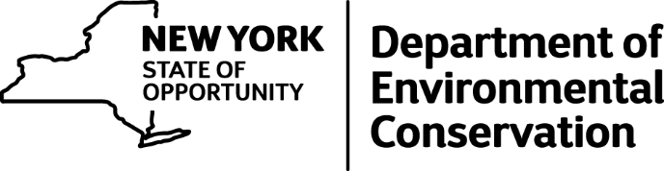

DEC Environmental Conservation Officer Highlights

ECO Actions for Late June
New York State Department of Environmental Conservation Environmental Conservation Officers (ECOs) enforce the 71 Chapters of NY Environmental Conservation Law, protecting fish and wildlife and preserving environmental quality across New York.
In 2015, the 268 ECOs based across the state responded to 25,000 calls and issued 22,000 tickets for crimes ranging from deer poaching to corporate toxic dumping to illegal mining, black market pet trade and excessive emissions violations.
"From Montauk Point to Mount Marcy, from Brooklyn to Buffalo, the ECOs who patrol our state are the first line of defense in protecting New York's environment and our natural resources, ensuring that they exist for future generations of New Yorkers," said Commissioner Basil Seggos. "They labor through long and arduous hours, often deep in our remote wildernesses or in the tight confines of our urban landscapes, and without much public fanfare. But their work centers around the most important things we do at the DEC."
Recent missions carried out by ECOs include:
Bobcat Kitten Rescue -- Tioga County
On June 23 ECOs Brent Wilson and Stanley Winnick were contacted by Tioga County 911 Dispatch reporting a bobcat kitten stuck in a drainage ditch in front of a residence. When they arrived on the scene, an Owego police officer was there with a group of children. The complainant, who had located the bobcat, runs a daycare center out of her home and she, along with the children, were concerned about the bobcat. Apparently, the bobcat kitten sought shelter in a drain pipe for protection. The ECOs moved everyone away from the pipe and patiently waited for the bobcat to emerge. Eventually, it slowly crawled out, and ECO Wilson caught the kitten after a quick chase. ECO Wilson placed the kitten in a safe storage compartment in his truck. A local wildlife rehabilitator was nearby, setting a live trap for another bobcat kitten that had been abandoned. Both kittens are doing well and will be released to the wild when they become self-sufficient.
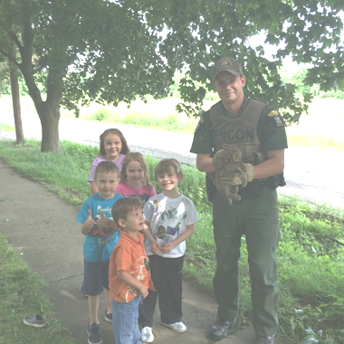
ECO Brent Wilson with bobcat kitten
Illegal Mobile Truck Wash -- Bronx County
On June 24 ECOs Jeannette Bastedo and Kimberly Garnsey were investigating a complaint they had received of a man operating a mobile truck wash in the Mott Haven section of the Bronx. While patrolling the area they observed a man using a generator, a power washer, a scrub brush, and industrial strength aluminum cleaner to clean a truck cab and engine on the street. The man had no way to catch and contain all the oil, grease, dirt, and acid-based aluminum cleaner from landing on the roadway, running down the street, and draining into a storm sewer. As soon as the man was approached he stated, "I know I'm not supposed to do this. I know I am in the wrong. I will take responsibility." The man was given summonses for Depositing a Noisome and Unwholesome Substance on a Public Highway and for Disposing of a Noxious and Offensive Substance into a Sewer.
Illegal Pesticide Use - Erie County
ECO Chuck Wilson responded to a complaint at the Winsong Medical Park in the town of Amherst in late May after a complainant had observed a maintenance worker intentionally spray a Canada Goose with a chemical, and destroying the goose's nest. Officer Wilson conducted interviews, obtained a written statement from the witness, and examined the remnants of the nest. DEC pesticides staff responded to assist the investigation, collecting samples from the remains of the nest and from the pump sprayer that the suspect had used. Lab results confirmed all samples for glysophate, the active ingredient in the widely available herbicide Round-Up. The man was charged with Unlawful Attempt to take Wildlife by the Use of a Pesticide and Failure to Use a Pesticide in Accordance with Labeling Instructions on June 28 in Amherst Town Court. His employer was charged with Allowing Commercial Application of a Pesticide without Certification.
How Not to Operate a Paint Shop -- Bronx County
On June 30 in Hunts Point, ECO Edward Piwko observed two individuals spray painting cars on the sidewalk and in an open bay garage. ECO Piwko noticed the garage was labeled as a repair business and stopped to check on the two men as they were not wearing any protective gear, engulfed in a fog of paint. As ECO Piwko exited his patrol car he observed that excess paint, oil and vehicle fluids were flowing down the city street into a storm drain. ECO Piwko made the employees immediately stop all work and contacted the owner. Once the owner arrived on scene, ECO Piwko did a walkthrough of the garage, pointing out a list of offenses and safety concerns. The owner was issued eight New York City summonses for Environmental Conservation Law violations, including discharging waste to a storm drain without a SPDES permit, three misdemeanors for various air quality violations, and four violations for oil and chemical storage. The owner faces up to $70,000 in fines and over a year in jail. He is due in Bronx County Court in October.
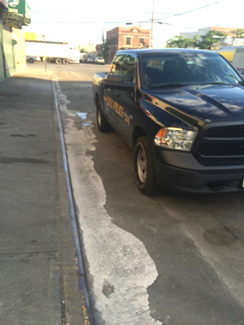
Run off from illegal auto painting operation in the Bronx.
If you witness an environmental crime or believe a violation of environmental law occurred please call the DEC Division of Law Enforcement hotline at 1-844-DEC-ECOS (1-844-332-3267).

