DEC Environmental Conservation Officer Highlights

ECO Actions for Late June to Early July
New York State Department of Environmental Conservation Environmental Conservation Officers (ECOs) enforce the 71 Chapters of NY Environmental Conservation Law, protecting fish and wildlife and preserving environmental quality across New York.
In 2015, the 268 ECOs based across the state responded to 25,000 calls and issued 22,000 tickets for crimes ranging from deer poaching to corporate toxic dumping to illegal mining, black market pet trade and excessive emissions violations.
"From Montauk Point to Mount Marcy, from Brooklyn to Buffalo, the ECOs who patrol our state are the first line of defense in protecting New York's environment and our natural resources, ensuring that they exist for future generations of New Yorkers," said Commissioner Basil Seggos. "They labor through long and arduous hours, often deep in our remote wildernesses or in the tight confines of our urban landscapes, and without much public fanfare. But their work centers around the most important things we do at the DEC."
Recent missions carried out by ECOs include:
Tug boat accident at Tappan Zee Bridge - Rockland County
On June 30, 2016, ECO Dawn Galvin responded to a tug boat accident near Pier 15 of the Tappan Zee Bridge on the Rockland County side of the Hudson River. ECO Galvin confirmed that the tug boat Potomac sank in nine feet of water. The partially submerged 47-foot-long tug boat had two crew members, both of whom were able to get off the tug boat unharmed. The boat contained up to 1,500 gallons of petroleum products, but no sheen was observed. ECO Galvin stayed on scene until the tug was raised, dewatered and able to float on its own. The tug was then moved to a Tappan Zee maintenance barge and then to Pederson's Marina in Nyack. No spill or release of hazardous materials occurred.
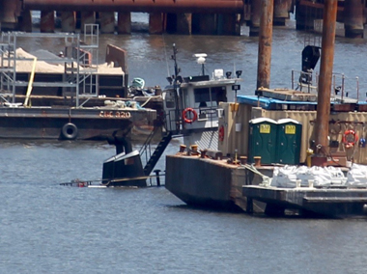
Sunken Tug Boat near the Tappan Zee Bridge
Illegal Reptile Purchase in Stony Brook - Suffolk County
ECO Ron Gross recently spotted a Black Throat Monitor and an American Alligator advertised for sale on Craigslist. Both species are illegal to own in New York, and the map on the ad showed the listing in an area in Queens. ECO Gross forwarded the information to Queens ECO John Gates. ECO Gates began texting the subject on an undercover phone and through his messaging was able to set up a time to purchase the Monitor for $350, although the Alligator had already been sold. ECO Gates was told to meet in Stony Brook to pick up the animal, not Queens. ECOs Gates and Gross met with the seller at his house on June 30 in plain clothes and confirmed that the Monitor was there. Once the seller brought the monitor out of the house, ECOs Mark Simmons, Marcia Goodrich and Lt. Tom Gadomski, who were waiting nearby, responded and took possession of the animal. The seller was charged with Illegal Possession of a Black Throat Monitor Without a Permit. The owner allowed the ECOs to search the house and no other illegal animals were found. The Monitor was seized and turned over to the Suffolk County SPCA for rehoming.
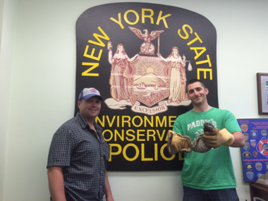
ECOs Ed Piwko and John Gates with the Black Throat Monitor
Illegal Hunting for Deer and Small Game at Night - Livingston County
On Friday, July 1, ECO Brian Wade received a call from a local New York State Police Trooper regarding a traffic stop he had just made involving a "shots fired" complaint in the town of Mount Morris. The Trooper explained that the three men he had stopped claimed to be hunting porcupines. This was odd considering it was after 11 p.m. ECO Wade responded to the scene to assist the Trooper and after collecting evidence, including deer hair and blood from a dent on the side of the truck, empty shell casings from inside the truck and a dead woodchuck from the back of the truck, he determined that the men were also involved in illegal deer hunting. The Trooper also recovered three loaded firearms and a flashlight from the truck. The occupants of the truck gave both the Trooper and ECO Wade multiple conflicting versions of the evening's events but eventually the stories unraveled. The men had killed two raccoons out of season, attempted to kill one deer unsuccessfully, and successfully killed a large buck in a hay field nearby. All of these offenses allegedly occurred from inside the vehicle while using lights on public roads or driving through farm fields. The men eventually brought ECO Wade to a dead whitetail buck. The driver of the vehicle explained that as they chased the deer through the field as all three men repeatedly shot at it with pistols from the moving vehicle. At one point, the deer ran into the side of the vehicle denting it and leaving blood and hair on the vehicle. The men were each charged with five firearms and hunting related misdemeanors under Environmental Conservation Law in the Mount Morris Town Court.
Eastern Timber Rattlesnake (Ulster County)
On July 1 at 7 p.m., ECO Myles Schillinger was contacted by dispatch to respond to a complaint of a rattlesnake in a yard at a residence in Mount Tremper. ECO Schillinger responded and contacted Nuisance Wildlife Agent, Roy Lane, to assist in the capture of the snake. Lane arrived and the 3-foot-long Eastern Timber Rattlesnake was located, captured and relocated several miles away on state land. The homeowner was thankful for the removal of the Eastern Timber Rattle Snake and the rapid response of Officer Schillinger and snake wrangler Roy Lane.
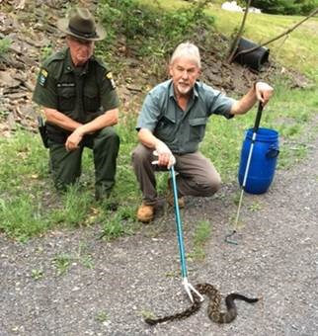
ECO Myles Schillinger and Roy Lane with Eastern Timber Rattlesnake.
Illegal Clamming in Jamaica Bay - Queens County
On July 3 while investigating a complaint of illegal fishing, ECOs Bradley Buffa, Jason Hilliard, and Waldemar Auguscinski spotted a large group of people clamming in Jamaica Bay off Broad Channel, an area that is closed to the taking of clams due to pollution concerns. Initially they encountered three people walking out to a parking area with containers full of clams. The ECOs issued each of the three tickets for Taking Clams from Uncertified Lands. ECOs then observed a second group of clammers walking to the parking area and identified themselves. Two members of the second group attempted to flee but were quickly apprehended by the ECOs. In total, the second group possessed more than 3,000 illegal clams. Each of the nine subjects were issued tickets for Taking Clams from Uncertified Lands and for Taking More Than 100 Clams without a Permit. All of the clams were returned to the waters of Jamaica Bay.
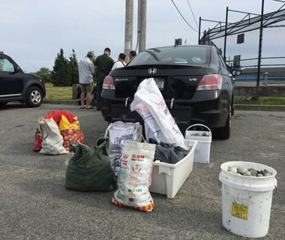
ECOs sorting and counting illegally taken clams.
Fawn Rescued from Basement Foundation - Saratoga County
On July 5, ECO Steve Shaw received a phone call from the Town of Clifton Park Animal Control Officer requesting assistance with a trapped fawn. The young deer had fallen more than 10 feet into a basement foundation of a new home under construction and could not escape on its own. ECO Shaw responded to assess the situation with individuals from North Country Wild Care, a local non-profit organization that assists with wildlife rehabilitation. It was determined the fawn was in good health, and adult deer tracks were spotted around the area. A plan was made to capture and release the fawn back into the wild. The fire department was contacted to bring an extension ladder, and North Country Wild Care was in possession of a large transport cage. ECO Shaw and the two members from North Country Wild Care climbed down into the foundation, cornered and threw blankets over the fawn, and moved the deer into the transport cage. ECO Shaw carried the fawn up the ladder and it was released into a wooded area nearby.
Fawn trapped in basement foundation
If you witness an environmental crime or believe a violation of environmental law occurred please call the DEC Division of Law Enforcement hotline at 1-844-DEC-ECOS (1-844-332-3267).

