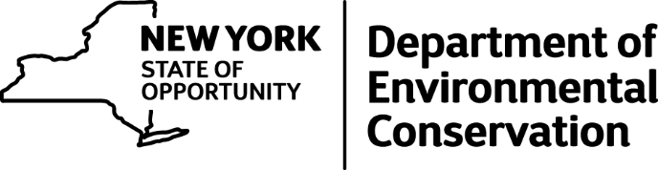

Informal Comment Period Open for Proposed Changes to Free Fishing Days
DEC is considering expanding the number of free fishing days that are offered and wants to set those days in regulation so they are consistent from year to year. This initial public review process will assist DEC in determining if it will move forward with this proposal to formally establish these additional free fishing days.
In addition to Free Fishing Weekend (last full weekend of June), the proposed rulemaking will specifically designate six additional Free Fishing Days that will occur throughout the year.
The proposed dates are as follows:
- Presidents Day Weekend (February) – Saturday and Sunday before Presidents Day
- 3rd Weekend in May
- National Hunting and Fishing Day (4th Saturday in September)
- Veteran's Day

How to submit comments
To submit comments regarding the proposal, send an email to regulations.fish@dec.ny.gov with the following subject line: "Possible Amendment to Free Sport Fishing Days." To ensure we receive and can properly review your suggestions, you must leave the subject line as it appears on the email.
Input will be collected through August 31, 2016
Make an informal comment
Note: Due to the expected high volume of e-mails received, DEC will be unable to reply to individual submissions, but all input will be reviewed and considered towards developing a proposed rule-making that, if accepted, would become effective in 2017.

