DEC Environmental Conservation Officer Highlights

ECO Actions for Mid-October
New York State Department of Environmental Conservation (DEC) Environmental Conservation Officers (ECOs) enforce the 71 Chapters of NY Environmental Conservation Law, protecting fish and wildlife and preserving environmental quality across New York.
In 2015, the 268 ECOs across the state responded to 25,000 calls and issued 22,000 tickets for crimes ranging from deer poaching to corporate toxic dumping and illegal mining, black market pet trade, and excessive emissions violations.
"From Montauk Point to Mount Marcy, from Brooklyn to Buffalo, the ECOs patrolling our state are the first line of defense in protecting New York's environment and our natural resources, ensuring that they exist for future generations of New Yorkers," said Commissioner Basil Seggos. "They work long and arduous hours, both deep in our remote wildernesses and in the tight confines of our urban landscapes. Although they don't receive much public fanfare, the work of our ECOs is critical to achieving DEC's mission to protect and enhance our environment."
Recent missions carried out by ECOs include:

Call Leads to Discovery of Box Turtle - Chemung County
On Oct. 7, ECO John Lifrieri investigated an anonymous complaint regarding a live snapping turtle in the town of Southport. It is illegal to possess live wildlife without a permit, and snapping turtles were out of season in September if hunted. ECO Lifrieri interviewed the suspect and quickly discovered he was keeping a turtle in the back of his pickup truck. It was also identified to be a box turtle, which is fully protected with no open hunting seasons. The subject said he only had it for a few days and was getting ready to return it to the boat launch on the Chemung River in Wellsburg. The subject was ticketed for unlawfully possessing protected wildlife. The ECO seized the turtle and contacted a wildlife rehabilitator. The licensed rehabber currently taking care of the turtle, observed that it was underweight and malnourished. The violator's case will be heard in the Town of Southport Court.
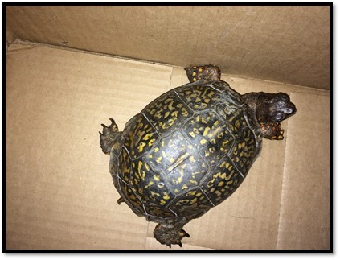

Scrap Metal Burn - Wayne County
On Oct. 10, ECO Kevin Thomas was driving down a back country road on patrol in the town of Rose and saw blue and black smoke coming from behind a trailer. When he investigated, ECO Thomas found an individual standing over a burn barrel with numerous pieces of scrap metal laying around the barrel and in his pickup truck. Most of the metal pieces were small engine starters with a copper interior. The man said he burned the machinery to obtain the copper and then planned to sell it back to the scrap yard. In all, more than 50 engine starters were discovered, allegedly violating open burning laws. ECO Thomas issued the subject a ticket for illegal open burn.
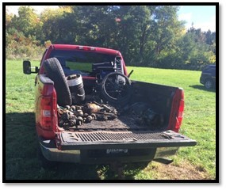

Full Moon Striped Bass Detail - Nassau and Suffolk Counties
On Friday Oct. 14 and Saturday Oct. 15, Region 1 ECOs conducted a Long Island striped bass detail under a full moon. The officers worked with members of the U.S. Coast Guard Station Fire Island on vessels and shore side. ECOs checked striped bass fishermen during this important lunar phase of the year, and the fishermen were out in full force as the striped bass have been running small of late. Besides the striped bass, other illegal fish violations were discovered, with many of the species being undersized fish used as striped bass bait. By the end of the two-night patrol, more than 36 tickets were issued for undersized porgy, blackfish, black sea bass, oyster toad fish, over-the-limit hickory shad, out-of-season fluke, lack of marine registries, lack of navigation lights, and lack of PFDs on board.
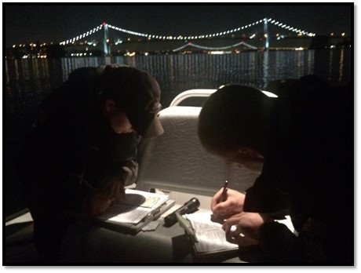

Joint Checkpoint Yields Loaded Firearms, Drug Violations - Franklin and St. Lawrence Counties
On Oct.16, ECOs from Region 5 and 6 and New York State Troopers conducted a joint checkpoint on Route 3 at the county line. The focus of the checkpoint was to identify hunting and deer violations. A large volume of hunters were checked, and three loaded firearms in motor vehicles were discovered. Several deer were checked and found to be in compliance with tagging requirements. In addition to the firearms violations, Penal Law, Public Health Law, and ABC Law violations were also discovered. State police made several arrests for violations ranging from criminal possession of a controlled substance to unlawful possession of marijuana, possession of alcohol by persons under 21, and possession of controlled substance not in its original container.
If you witness an environmental crime or believe a violation of environmental law occurred please call the DEC Division of Law Enforcement hotline at 1-844-DEC-ECOS (1-844-332-3267).
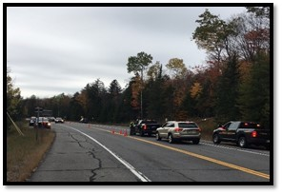
ECOs interviewing a motorist
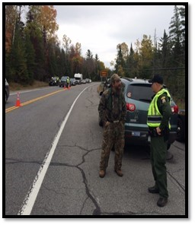
ECOs checking hunters
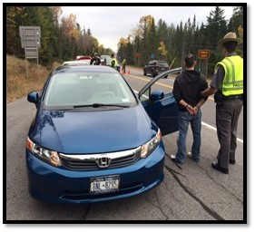
Trooper arresting a subject for drug violations

