DEC Environmental Conservation Officer Highlights

ECO Actions for Mid to Late September
New York State Department of Environmental Conservation (DEC) Environmental Conservation Officers (ECOs) enforce the 71 Chapters of NY Environmental Conservation Law, protecting fish and wildlife and preserving environmental quality across New York.
In 2015, the 268 ECOs across the state responded to 25,000 calls and issued 22,000 tickets for crimes ranging from deer poaching to corporate toxic dumping and illegal mining, black market pet trade, and excessive emissions violations.
"From Montauk Point to Mount Marcy, from Brooklyn to Buffalo, the ECOs patrolling our state are the first line of defense in protecting New York's environment and our natural resources, ensuring that they exist for future generations of New Yorkers," said Commissioner Basil Seggos. "They work long and arduous hours, both deep in our remote wildernesses and in the tight confines of our urban landscapes. Although they don't receive much public fanfare, the work of our ECOs is critical to achieving DEC's mission to protect and enhance our environment."
Recent missions carried out by ECOs include:
Ginseng Theft from State Land - Delaware County
On September 16, ECO Nathan Doig received an anonymous tip that a subject from Margaretville was parked near Miller Hollow Road in the Town of Colchester, illegally taking ginseng from a local hunting club's property. ECO Doig responded and located the subject's vehicle near State Forest Preserve lands. He contacted ECOs George Wilber and Kyle Bevis, a recent graduate of DEC's 20th Basic School, to assist him. ECOs Wilber and Bevis spotted a man dressed in camouflage walk from the woods and drive off. They stopped the car and found the suspect in possession of 26 ginseng roots taken from state land. The ginseng was seized and the subject was issued an appearance ticket returnable to Colchester Town Court in October for illegally harvesting ginseng on the Forest Preserve.
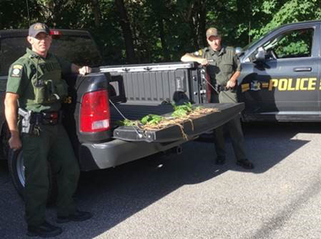
ECOs with illegally harvested ginseng plants.
Dairy Farm Tire Fire - Franklin County
On September 17, ECOs Jennifer Okonuk and Zach Brown were called by Franklin County 911 to respond to a tire fire in the Town of Westville. The Westville Fire Department was on the scene and had requested DEC Police for enforcement. When the ECOs arrived on scene there were six fire departments, Franklin County Deputy Fire Coordinators, the Franklin County Rehab Team, and the Franklin County Fire Police working to extinguish the fire. The area burning was in excess of 10,000 square feet and included an old house with a foundation containing thousands of empty agricultural feed bags and more than 200 waste tires. The Westville Fire Chief advised the ECOs that the farmer was not cooperating. The ECOs explained the situation to the farmer, however, neither the farmer nor his employees were able to explain how the fire had started. The ECOs issued the farmer tickets for the open burning of garbage, producing unreasonable odor or fumes, maintaining an unattended open fire, and the unlawful disposal of solid waste. The charges will be heard by the Town of Westville Court.
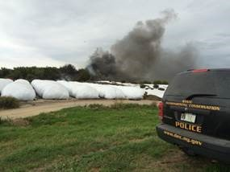
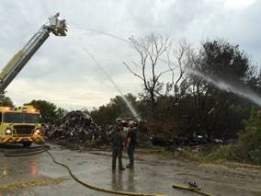
ECO Zach Brown observes efforts to extinguish the
large pile of solid waste.
K-9 Tracks Hunters Baiting Bear - Sullivan County
On September 18, ECO K-9 Officer Ricky Wood received information that at least two men were hunting bear over bait off of Lake House Road in the Town of Fallsburg. Responding to the location, the ECO observed the parked green Tahoe reported by the complainant. ECO Wood contacted ECOs Josh Sulkey and Will Chomicki, a recent graduate of DEC's 20th Basic School, to assist him. ECO Wood deployed K-9 Deming to track the hunters from their vehicle. K-9 Deming quickly led the ECOs to one of the hunters, who was found hunting bear with the aid of bait. The second hunter was located shortly thereafter and also observed hunting bear with the aid of bait, in addition to tracking what he claimed was a bear he had hit with an arrow. The second hunter was found to be in possession of an unpermitted .44 caliber revolver. The hunters' firearms, bow, and other hunting equipment were secured in the ECO's patrol vehicles and the officers and hunters returned to the woods to locate and recover the dead bear. The two hunters were charged with hunting bear with the aid of pre-established bait. The second hunter was also charged with the illegal taking of wildlife and for failing to report his previous-season deer harvest. The Fallsburg Police Department charged the second hunter with the illegal possession of a firearm. All charges are pending in the Town of Fallsburg Court. The bear meat was donated to a needy family.
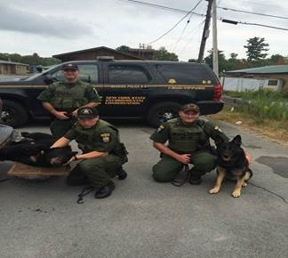
K9 Deming, ECOs and the illegally hunted bear.
Goose Hunters Found Intoxicated Hunting After Hours - Franklin County
On September 18, ECOs Jennifer Okonuk and Zach Brown were on patrol in the Trout River State Forest in the Town of Constable when they noticed a vehicle with waterfowl stickers parked off the side of the road. The ECOs could hear hunters calling geese in a nearby wetland and saw shotgun shells on the front seat of the vehicle. The ECOs were also able to confirm electronically that the registered owner of the vehicle had an expired hunting license. The ECOs waited for the hunters to exit the woods. At 7:28 p.m., past legal hunting hours, a flock of geese flew over the ECOs and toward the hunters. Moments later, the ECOs heard eight shots and saw two geese fall from the sky. Moments later, two hunters came out to the parked truck and the ECOs checked their firearms and licenses and observed that they appeared to have been consuming alcohol. Both of the hunters' licenses had expired on August 31, and both of them had been hunting with shotguns that were not plugged to hold only three rounds of ammunition. One of the hunters failed field sobriety tests and was arrested and transported to the local New York State Police barracks, where he submitted to an alcohol test. He was found to be legally intoxicated and charged with hunting while impaired by alcohol. The ECOs issued six additional tickets to the hunters. Both were charged with hunting without a hunting license, shooting during closed hours, and hunting waterfowl with a shotgun capable of holding more than three rounds.
Black Wolf Mount for Sale - Hamilton County
On September 18, ECO Keith Kelly received a complaint that a large black wolf mount was being offered for sale at the Adirondack Mountains Antiques Show in Indian Lake. Officer Kelly responded and observed the wolf on display without a price tag. After interviewing visitors at the show, he learned that the vendor was asking $2,500 for the mount. The vendor could not produce any permits to possess the wolf and was issued a ticket for offering an endangered species for sale without a permit. The wolf was seized as evidence and will be forfeited if the vendor is found guilty of the charge.
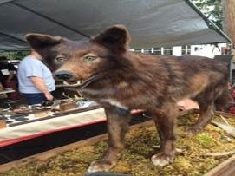
Black wolf mount illegally offered for
sale in Indian Lake.
If you witness an environmental crime or believe a violation of environmental law occurred please call the DEC Division of Law Enforcement hotline at 1-844-DEC-ECOS (1-844-332-3267).

