DEC Environmental Conservation Officer Highlights

ECO Actions for Late September
New York State Department of Environmental Conservation (DEC) Environmental Conservation Officers (ECOs) enforce the 71 Chapters of NY Environmental Conservation Law, protecting fish and wildlife and preserving environmental quality across New York.
In 2015, the 268 ECOs across the state responded to 25,000 calls and issued 22,000 tickets for crimes ranging from deer poaching to corporate toxic dumping and illegal mining, black market pet trade, and excessive emissions violations.
"From Montauk Point to Mount Marcy, from Brooklyn to Buffalo, the ECOs patrolling our state are the first line of defense in protecting New York's environment and our natural resources, ensuring that they exist for future generations of New Yorkers," said Commissioner Basil Seggos. "They work long and arduous hours, both deep in our remote wildernesses and in the tight confines of our urban landscapes. Although they don't receive much public fanfare, the work of our ECOs is critical to achieving DEC's mission to protect and enhance our environment."
Recent missions carried out by ECOs include:

Unlawful Possession of a Raccoon - Yates County
On September 15, ECOs Josh Crain and John Rich were called for a complaint of an individual in possession of a raccoon as a pet in the Town of Jerusalem. Upon arriving at the residence, the ECOs were greeted by a female who claimed she did not possess a raccoon. After interviewing the male property owner and the woman, the woman admitted to keeping a pet raccoon in the house for several months. The male took responsibility for the raccoon and turned it over to the ECOs, who transported it to a local wildlife rehabilitator. The ECOs issued the man an appearance ticket for possession of wildlife other than permitted by law.

Taking Out the Trash - Seneca County
On September 16, ECOs John Rich, Joshua Crain, Scott Angotti, and Tony Drahms were on boat patrol in the Town of Tyre when they found an illegal dumping site along the Erie Canal. The dumping site consisted of household trash, old furniture, liquor bottles, and cardboard packaging. The officers found mail with two separate Auburn addresses mixed into the pile of trash and located the subject on September 19. ECOs Angotti and Drahms discovered that the man had been ticketed in the past for open burning. The subject worked for several people in the Auburn area and dumped the solid waste in the woods instead of taking it to the dump. The subject at first denied the allegations, but quickly changed his story when confronted with the evidence. A ticket was issued for illegal disposal of solid waste for a Tyre Town Court date in October.
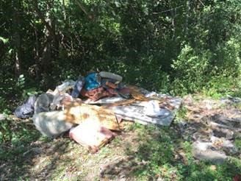
Garbage dumped along the Erie Canal.

School of Holy Childhood Fishing Clinic - Monroe County
On September 19, Lts. Matt Lochner and Bruce Hummel along with ECOs Gary Wilson, Scott Angotti, Josh Crain, Tony Drahms, and John Rich hosted a fishing event for the students of the School of the Holy Childhood, a school for individuals with intellectual and developmental disabilities. The much-anticipated event is a decades-long, annual tradition. This year's fishing destination was Powder Mills Park in the Town of Perinton. The event was made possible by support from the New York State Conservation Officers Association and the Riedman Foundation Fish Hatchery. The event is aimed at teaching children and young adults the basics of fishing. The ECOs assisted in teaching 16 students how to fish. Many of the participants had never fished before and were excited to start learning.
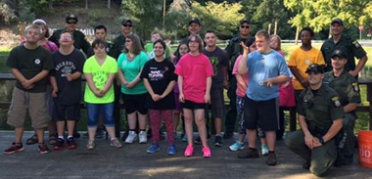
ECOs with students from the School of the Holy Childhood.

"SAFE Boat" Captains Course - Lake Ontario
Five of the recent 31 graduates of the Division of Law Enforcement 20th Basic School for Uniformed Officers recently transferred to the Marine Enforcement Unit (MEU) where they will become specialists in marine fisheries law while operating DEC's largest patrol vessels in and around New York Harbor. The five new ECOs began extensive field training in September in the 132-hour A-Platform School, officially known as the "SAFE Boat Captains Course." The training involved operation of DEC's larger patrol vessels, navigation and seamanship, vessel electronics and charting, mooring techniques, rough water operations, night operations, towing, and waterborne arrest techniques. Two weeks of the course were spent almost entirely operating the large vessels on Lake Ontario. To successfully complete the course, each ECO had to demonstrate precision and efficient competency in all of the tasks required to be a vessel operator in New York's Marine District. The training concluded on September 23 with nine ECOs completing the course, including the five recent graduates. One of the graduates, ECO Mary Grose, is the DEC's first female to serve as a SAFE Boat Captain.
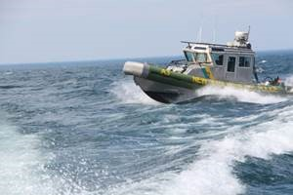
Rough weather operations
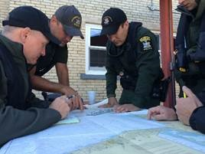
ECOs practicing chart plotting.

Side Job Selling Illegal Fish - Kings County
On September 23, ECO Jeff Krueger investigated a complaint of a husband and wife keeping undersized fish in the back of their vehicle at a local marina. ECO Krueger watched as the boat described in the complaint returned to the marina with two males and a female transferring coolers and a bucket off the boat and into the vehicle. ECO Krueger followed the vehicle until the trip ended in Chinatown in Brooklyn at a known live fish dealer and frequent violator of the Environmental Conservation Law. ECO Krueger made contact with the female after one of the males entered the seafood shop to sell fish and discovered the aerated cooler in the back of the vehicle containing 55 live black sea bass and one summer flounder. At least 52 of the sea bass measured less than the legal size limit of 15 inches. The male explained to ECO Krueger that he and his wife just wanted to make some extra money and that he usually gets $6 per pound for the fish. The husband and wife team received summonses for landing commercial food fish without a permit, commercial shipping and dealing food fish without a permit, possession of undersized and over limit black sea bass, and possession of fluke out of season. The couple is scheduled to appear in Kings County Court to answer the summonses.

Marijuana Grow Site Discovered - Franklin County
Marijuana plants were not exactly what ECO James Cranker was searching for on the second weekend of early bear hunting season. While on foot patrol on September 24, ECO Cranker was checking for bear hunting activity in the Kushaqua Conservation Easement area in the Town of Franklin and discovered marijuana plants growing in a wetland area. A lightly used foot path caught his attention as a possible bear hunting site so he followed it into the swampy area. However, the path ended at a marijuana garden instead. The plants were removed and destroyed and the investigation into those responsible for growing the plants continues.
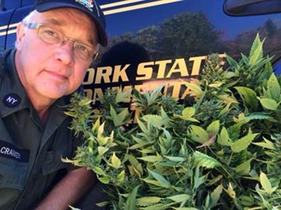
ECO Cranker with seized marijuana plants.

