DEC Environmental Conservation Officer Highlights

ECO Actions for Late August and Early September
New York State Department of Environmental Conservation (DEC) Environmental Conservation Officers (ECOs) enforce the 71 Chapters of NY Environmental Conservation Law, protecting fish and wildlife and preserving environmental quality across New York.
In 2015, the 268 ECOs across the state responded to 25,000 calls and issued 22,000 tickets for crimes ranging from deer poaching to corporate toxic dumping and illegal mining, black market pet trade, and excessive emissions violations.
"From Montauk Point to Mount Marcy, from Brooklyn to Buffalo, the ECOs patrolling our state are the first line of defense in protecting New York's environment and our natural resources, ensuring that they exist for future generations of New Yorkers," said Commissioner Basil Seggos. "They work long and arduous hours, both deep in our remote wildernesses and in the tight confines of our urban landscapes. Although they don't receive much public fanfare, the work of our ECOs is critical to achieving DEC's mission to protect and enhance our environment."
Recent missions carried out by ECOs include:

First Day on the Job Leads to Snake Wrangling - Suffolk County
On the morning of September 6, ECOs Jeff Hull, Marcia Goodrich, Emma Carpenter and Lieutenant Matt Blaising responded to a call from Suffolk County SPCA regarding a reptile owner who was bitten several hours earlier by his Egyptian saw-scaled viper, one of six venomous snakes he kept in his basement. In addition to the viper, the young man also owned an eastern diamondback rattlesnake, a western diamondback rattlesnake, an African puff adder, a monocled cobra (one of the deadliest snakes in the world) and a West African gaboon viper. After being airlifted to Jacobi Medical Center, the victim was determined to have suffered a "dry bite," a wound in which no venom is injected into the victim's bloodstream. The consulting herpetologist stated that if the owner had received a full bite by that snake, or by any of the other five snakes for that matter, he likely would've died within an hour. Long Island seems to be the epicenter for the possession of illegal venomous reptiles within New York State, with ECOs continually seizing illegal venomous reptiles. For ECO Carpenter, having just graduated DEC 21st Basic Academy on Friday, September 2, this was her first day on the job. An hour into her first shift, she found herself, with the help of a herpetologist, seizing some of the deadliest snakes in the world. The owner of the snakes was issued summonses for six counts of possession of wildlife without a permit and another six counts of possession of dangerous venomous wildlife. All the snakes were turned over to a licensed venomous wildlife educator out of Massachusetts.
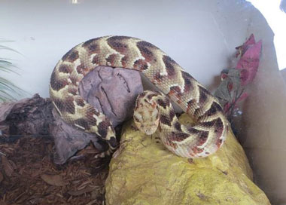
An African Puff Adder snake found inside a home in
Suffolk County

Assortment of Short Fish - Queens County
On August 23, ECO Brad Buffa was conducting marine fishing compliance checks along Beach Channel Drive in the Rockaways when he approached two fishermen who seemed unusually nervous. The ECO observed a plastic bag that appeared to contain undersized fish hidden behind a rock and asked the men if they had any fish, to which they replied "no." ECO Buffa inspected the bag and found that it contained undersized fish. He also located a second bag hidden nearby that contained more undersized fish. In all, the fishermen were found to be in possession of 17 undersized black sea bass, 10 undersized porgies and one undersized summer flounder. Six summons were issued for the multiple violations.
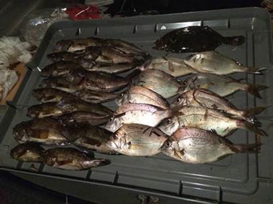
An assortment of short fish

Illegal Spraying - Ulster County
On August 23, ECO Joshua Sulkey was on patrol in the town of Rochester when he observed an individual spraying shrubs at a residence. A closer look revealed that the subject was spraying a commercial insecticide. ECO Sulkey inquired if the individual was a certified applicator and if the company he worked for was a registered pesticide business. The pesticide applicator stated that he was not certified and wasn't sure if the company was registered. ECO Sulkey contacted DEC staff and they confirmed that the company was not registered. The company was issued tickets for operating an unregistered pesticide business and for applying pesticides without being a certified applicator. They were also advised of several other violations that were observed and how to correct the issues.

Stacks of Sea Bass - New York County
On August 25, a Chinatown fish market was convicted of unlawfully possessing undersized Black Sea Bass, Tautog (Blackfish) and possessing untagged shellfish. The case stemmed from a routine market check in February, when ECOs uncovered eight crates containing 436 undersized black sea bass. The fish ranged from 9 to 10 1/2 inches in length. The commercial minimum size limit for black sea bass is 11 inches, and the fishery is a heavily regulated/quota-managed species due overfishing. In addition to the undersized sea bass, the market also received summons for the sea bass crates being untagged as required by law, possession of undersized Tautog, and a box of untagged shellfish containing blood clams. The market was fined $1,500 and the unlawfully possessed fish were donated to City Harvest, a provider for local homeless shelters.
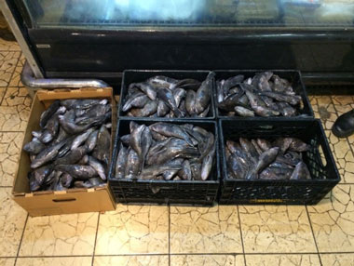
Illegal fish in a Chinatown market

Rattlesnake Wrangling - Delaware County
On the morning of August 25, ECO George Wilber responded to a 911 call of a rattlesnake at the French Woods Festival of the Performing Arts Group in the town of Hancock. While en-route, the officer spoke to Randy Stechert, a reptile and amphibian specialist from Narrowsburg, who also responded to the festival. Together Stechert and ECO Wilber collected, transported and safely released the 47-inch yellow morph timber rattlesnake in a suitable setting without incident.
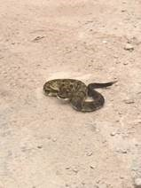
The rattlesnake prior to
being captured

Range Safety - Genesee County
On August 27, ECO Gary Wilson responded to a complaint of subjects consuming alcohol at the public shooting range in the Tonawanda Wildlife Management Area. The complainant stated that there were several individuals with firearms who were drinking alcohol and speaking Russian. ECO Wilson responded to the area along with New York State Police, the Genesee County Sheriff's, and U.S. Border Patrol. The officers found four Ukrainian subjects who admitted to consuming alcohol, but had not yet removed their weapons from their cases, as they were waiting their turn to use the range. The subjects were in possession of a total of eight long guns. Four of the long guns were claimed to be owned by one subject who stated he had legal alien status. The other four firearms were claimed by a subject stating he was a U.S. citizen. Although the subject with legal alien status could legally possess a firearm, one of his four rifles was an unregistered AR-style assault weapon with a high capacity magazine. He was arrested by NYSP for a Class E Felony under the SAFE Act. One of the other four subjects was taken into custody by the USBP as he did not have legal citizen status.

Early Morning Start Leads to Overage - Suffolk County
On August 28, ECOs Jordan Doroski and Kevin Holzle got an early morning start to Montauk in order to meet up with U.S. Coast Guard Station Montauk personnel for a joint boat patrol. One particular commercial fishing vessel caught their attention as the ECOs prepared to head out onto the water. The boat appeared to be making its way in with the day's catch by 8:15 in the morning. ECOs Doroski and Holzle met the boat at the offloading dock and found the fisherman to be in possession of 358.9 pounds of summer flounder, over five times his daily limit. The fisherman also had not completed his vessel trip report (VTR) prior to landing. The ECOs documented the violations and issued appearance tickets for the overage and a summons for failing to complete the VRT. Fair market value of the overage was nearly $1,000, making it a misdemeanor level crime of illegal commercialization.
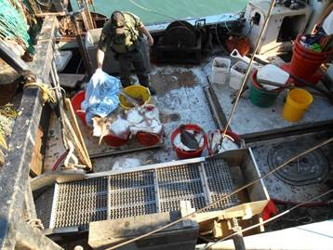
ECO Holzle documenting illegally possessed summer flounder

Black Duck Hooked by Floating Lure - Franklin County
On August 28, ECO Nathan Favreau was contacted by Ray Brook Dispatch indicating that DEC staff at Fish Creek Campground staff were requesting assistance with a black duck that had a fishing lure hooked to it. ECO Favreau arrived to find the duck by the Fish Creek outlet with both sets of treble hooks from the lure hooked to its head and wing. The animal, still able to fly, was able to evade capture on the first attempt. ECO Favreau and Jesse Gonyea, the campground caretaker, borrowed a large fishing net from a nearby camper and tried to corral the bird. The second attempt was also unsuccessful as the bird swam away from shore. For the third attempt, Gonyea and Park Ranger Pete Guerin used a boat to herd the bird toward shore, where it sought refuge underneath brush. With the help of a camper, ECO Favreau was then able to net the bird, remove the lure and return the duck to Fish Creek Ponds.
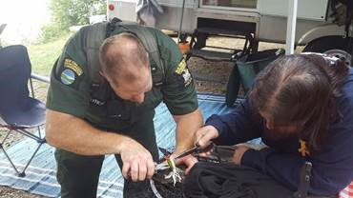
ECO Nathan Favreau and a camper working to free and
release the duck
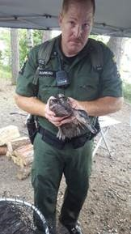

Timber Rattlesnake on Turtle Island - Warren County
On August 28 just after 10:30 pm, ECOs Rob Higgins and George Lapoint responded to a complaint of a timber rattlesnake and a group of frightened campers on Turtle Island in the Lake George Islands State Campsite in the town of Bolton. The ECOs responded by boat and arrived equipped with snake catching gear, including snake grabber poles, bags, gloves, and snake transportation containers. ECOs Higgins and Lapoint have both received specialized training in the handling of rattlesnakes due to the frequency of complaints of rattlesnake conflicts in the Lake George and southern Lake Champlain areas. The ECOs safely captured the rattlesnake and prepared it for transport back to the DEC facility in Green Island. The next morning, the ECOs contacted Dr. William Brown, a local rattlesnake expert, who will collect data from the rattlesnake and return it back to its habitat.
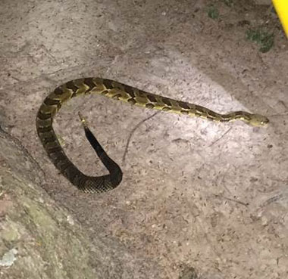
The mature rattlesnake removed by ECOs from
the Turtle Island campsite

