DEC Environmental Conservation Officer Highlights

ECO Actions for Early October
New York State Department of Environmental Conservation (DEC) Environmental Conservation Officers (ECOs) enforce the 71 Chapters of NY Environmental Conservation Law, protecting fish and wildlife and preserving environmental quality across New York.
In 2015, the 268 ECOs across the State responded to 25,000 calls and issued 22,000 tickets for crimes ranging from deer poaching to corporate toxic dumping and illegal mining, black market pet trade, and excessive emissions violations.
"From Montauk Point to Mount Marcy, from Brooklyn to Buffalo, the ECOs patrolling our state are the first line of defense in protecting New York's environment and our natural resources, ensuring that they exist for future generations of New Yorkers," said Commissioner Basil Seggos. "They work long and arduous hours, both deep in our remote wildernesses and in the tight confines of our urban landscapes. Although they don't receive much public fanfare, the work of our ECOs is critical to achieving DEC's mission to protect and enhance our environment."
Recent missions carried out by ECOs include:

Bald Eagle Success Story - Columbia County
An injured bald eagle rescued in the Hudson River on June 4 by ECOs James Davey and Anthony Glorioso was recently released in the town of Germantown. The female bald eagle had spent the last three-and-a-half months in the care of Triple FFF Wildlife Center in Hunter being treated for pneumonia and injured flight feathers. ECOs Glorioso, Davey, and Lucas Palmateer, along with Missy Runyan from the Triple FFF Wildlife Center, released the eagle in the area where she had been injured. DEC Bureau of Wildlife staff leg-banded the eagle for future data collection prior to the successful release.
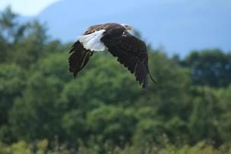
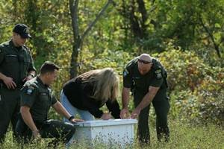
ECOs work with a wildlife rehabilitator to
release the healthy Bald Eagle.

2016 Youth Waterfowl Hunt - Niagara and Genesee Counties
ECOs from Region 8 and 9 recently teamed up for another successful youth waterfowl hunt. The event began at the Wyoming Valley Rod and Gun Club in the Village of Java with waterfowl I.D. and trap shooting classes. ECO Nathan VerHague and Lt. Joshua VerHague led class instruction and ECO Roger Ward ensured all participants had a safe and educational time on the trap field. On October 1, 13 young hunters took to the marshes of the Tonawanda Wildlife Management Area accompanied by the ECOs and several dedicated volunteers. The morning was slightly overcast, windy and rainy, and perfect for duck hunting. ECOs Marshall, Hunt, VerHague, Dougherty, Kroth, Rausher, Wilson, and Jakaub teamed with several experienced volunteer waterfowl hunters to expose the young hunters to one of New York's most revered hunting traditions. When the calling stopped, 27 ducks had fallen to the sharp shooting of the young hunters. The hunters then watched a demonstration on proper preparation of their harvest and were sent home with plenty gear and prizes, full stomachs and, hopefully, a new hobby that gives them a greater appreciation of the outdoors and wildlife.
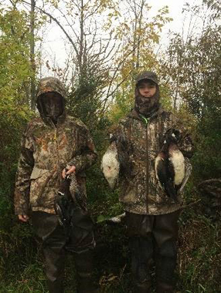
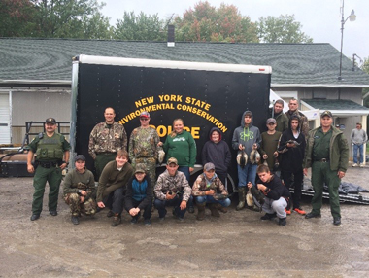
ECOs, volunteers, and young waterfowl hunters

Injured Raptor - Putnam County
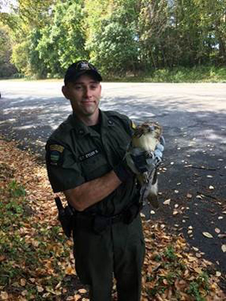
ECO Charles Eyler III and a distressed hawk.
ECOs Geoffrey Younglove and Charles Eyler III, recent graduates of DEC's 20th Basic School for Uniformed Officers, recently responded to a call of an injured hawk on Route 100 in the Town of Somers. The caller stated he saw the animal hopping across the highway and had stopped to make sure the bird wasn't in distress. He then realized there was something wrong with the bird and called DEC. The ECOs responded to the location and found that the hawk was lethargic and unable to fly. ECO Trainee Eyler captured the raptor. The bird was then transported to a local wildlife rehabilitator, who is nursing the bird back to health for release back into the wild.

Not a Fair Chase - Schoharie County
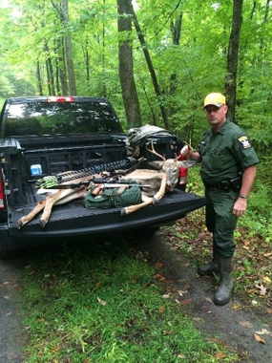
ECO Terrell with the illegally shot deer and
other evidence.
ECO Mike Terrell recently received an anonymous complaint about a person who had allegedly killed a large buck with the aid of illegal bait. After several lengthy foot patrols, ECO Terrell found a remote and well-hidden bait and tree stand. On October 1, the opening day of southern zone archery season, ECO Terrell and Lt. Tom Harrington hiked in at sunrise during heavy rains hoping to catch the subject bow hunting over the bait. As the ECOs approached the tree stand, a gun shot rang out. ECO Terrell quickly approached the tree stand and saw that the hunter was down on the ground and headed down a logging road. Believing the subject was fleeing the area, ECO Terrell identified himself and ordered the subject to stop. After the man was detained, the officer seized a small duffle bag containing a .22-caliber pistol equipped with a high-powered scope. The subject initially claimed that he had shot at a coyote. However ECO Terrell was able to track and locate a six-point buck approximately 60 yards from the tree stand. The man later admitted to killing the deer with the firearm. The man was charged in the Fulton Town Court for hunting over a pre-established bait pile, possession of a firearm during the special archery season, and the illegal taking of a deer.

DLE Welcomes DEC's First Female K-9 Handler - Oswego County
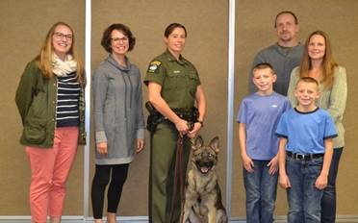
ECO Fuerch, K-9 Officer Handley and
Lt. Chris Handley's family.
On October 1, the Division of Law Enforcement recognized the arrival of its newest member in Region 6, K-9 Officer Handley, a German Shepherd named after the late Lt. Chris Handley, a revered member of the division. The ceremony at DEC's training facility in Pulaski was attended by Chris' widow, Debbie, their two children, Eric and Sara, as well as Eric's wife, Tami, and two grandchildren, Robert and Matthew. Deb Handley was introduced to K-9 Handley and was presented with a framed photo of the dog and his handler, ECO Fay Fuerch. ECO Fuerch is the first female K-9 officer in the 38-year history of DLE's K-9 program.

Owl Returned to the Wild - Washington County
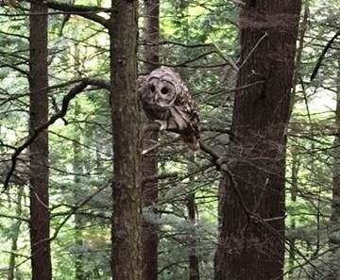
Barred Owl after being released by ECO Krug.
On July 18, ECO Matthew Krug was contacted by a concerned citizen regarding an injured Barred Owl in the Town of Dresden. After a brief search, the officer located the owl down a steep bank off County Route 6. ECO Krug determined that the bird was unable to fly and had likely been injured by an automobile. ECO Krug captured the owl and transported it to a local wildlife rehabilitator, North Country Wild Care. On October 2, the owl was released by ECO Krug back into the wild after being nursed back to full health by the rehabilitator.

Illegal Blackfish Dealer Busted - Queens County
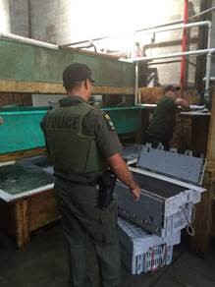
ECOs sorting and counting illegally
possessed blackfish.

