DEC Environmental Conservation Officer Highlights

ECO Actions for Early September
New York State Department of Environmental Conservation (DEC) Environmental Conservation Officers (ECOs) enforce the 71 Chapters of NY Environmental Conservation Law, protecting fish and wildlife and preserving environmental quality across New York.
In 2015, the 268 ECOs across the state responded to 25,000 calls and issued 22,000 tickets for crimes ranging from deer poaching to corporate toxic dumping and illegal mining, black market pet trade, and excessive emissions violations.
"From Montauk Point to Mount Marcy, from Brooklyn to Buffalo, the ECOs patrolling our state are the first line of defense in protecting New York's environment and our natural resources, ensuring that they exist for future generations of New Yorkers," said Commissioner Basil Seggos. "They work long and arduous hours, both deep in our remote wildernesses and in the tight confines of our urban landscapes. Although they don't receive much public fanfare, the work of our ECOs is critical to achieving DEC's mission to protect and enhance our environment."
Recent missions carried out by ECOs include:
Fish in the Sand - Bronx County
On September 1, ECO Jeannette Bastedo encountered a pair of fishermen at Orchard Beach who claimed not to have caught any fish. ECO Bastedo noticed boot prints in the wet sand leading to a suspicious mound a short distance away. Upon closer inspection, ECO Bastedo observed a fin sticking out of the sand. Hidden in the sand were four undersized porgies and an undersized striped bass. The men were ticketed for the undersized fish and failing to possess marine registries.
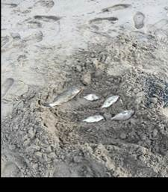
Undersized fish hidden in the sand
Ospreys Rescued at Sea - New York County
On September 2, while returning north from a cruise in Nassau, the crew of the Norwegian Gem discovered a pair of ospreys at daybreak on the top deck of the 965' ship. The ospreys were exhausted and appeared to have landed on the cruise ship during the night after being blown off course by Hurricane Hermine. The crew managed to contain the ospreys in cardboard boxes for the remainder of travel back to port in New York Harbor. ECOs Paul Pasciak and Jeff Krueger met the cruise ship at the terminal in Manhattan on the morning of September 3 to retrieve the ospreys. The ECOs transported the ospreys to a local wildlife rehabilitator, the Wild Bird Fund, and assisted with their examination. The birds were dehydrated but had no injuries. After a short stay with the rehabilitator the ospreys will be released back to the wild.
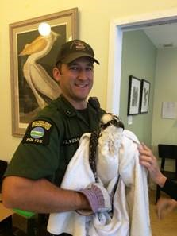
ECO Pasciak with one of the ospreys.
Lost Couple - Hamilton County
At 7:30 p.m. on September 3, a staff director at the Adirondack Bible Chapel Ministry Center in Lake Pleasant, which borders the Silver Lake Wilderness area, contacted off-duty ECO Scott Pierce at his home. The director informed ECO Pierce that two people at the center had gone for a walk and not returned, and that Ministry Center staff had been searching for the couple for two hours. ECO Pierce responded to the Ministry Center to assist the search and began to compile maps and information. Shortly thereafter, Forest Rangers Ploss and Thompson, retired Forest Ranger John Seifts, and two Hamilton County Deputies arrived. The group made several attempts to locate and/or signal the lost couple until 1 a.m. but were not successful. At 7 a.m. the next day, Ranger Ploss, eight Forest Rangers, and ECO Pierce continued the search. ECO Pierce and a church member used an ATV and chain saws to clear an old road. After approximately 45 minutes, they heard frantic calls coming from deeper into the forest. ECO Pierce took a compass bearing to the direction of the calls and located the couple approximately 300 yards in. They were happy to see him and in good shape considering having spent the night unprepared in the woods.
ECO Saves Overdose Victim - Onondaga County
While on his way to work at the New York State Fair on Sunday, September 4, ECO Don Damrath responded to a radio call from Onondaga County 911 Dispatch regarding an unresponsive male who was unconscious and not breathing in a parking lot. ECO Damrath was close to the Lafayette Dollar General store, where he observed a man slumped over in the passenger seat of his mother's car with drug paraphernalia next to him in the console. Feeling no pulse and seeing track marks on the man's arms, ECO Damrath immediately recognized the signs of a drug overdose. The man's mother confirmed he had been battling a heroin addiction for some time. ECO Damrath administered a full dose of Narcan (Naloxone Hydrochloride) just as EMTs arrived. Within 10 seconds the man showed signs of life, and within a minute, opened his eyes. After a few more minutes, the 29-year-old man was able to groggily converse with ECO Damrath, New York State Troopers, and the EMTs who responded to the call, admitting to being a heroin user but no recollection of that morning. He was taken by ambulance to a hospital for further treatment after tearfully thanking ECO Damrath.
Marijuana Eradication - Orleans County
On September 7, ECO Vernon Fonda and Lt. Joshua VerHague assisted the Orleans County Major Felony Task Force with a marijuana eradication detail. Other agencies included the Niagara County Felony Task Force and U.S. Customs and Border Patrol. Ninety-three plants were located and removed and three people arrested for unlawfully growing marijuana. Further charges are pending lab test results.
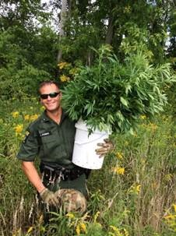
ECO Fonda with some of the marijuana seizure.
Commercial Vehicle Detail - Westchester County
On September 8, ECOs Dustin Dainack, Geoffrey Younglove, and Craig Tompkins participated in a commercial vehicle checkpoint with Pound Ridge and New York State Police. The ECOs checked everything from solid waste haulers and pesticide applicators to commercial seafood transporters. During the detail, the ECOs issued a total of three summonses related to pesticide violations. Overall, it was a valuable training day for ECO Tompkins, a recent graduate of the 20th Basic Academy, as he was exposed to a variety of enforcement situations and cooperative enforcement with other agencies.
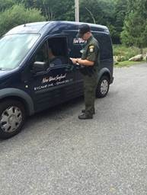
ECO Tompkins checks paperwork
from a commercial seafood business.
Illegal Crab Pots - Suffolk County
On September 8, ECOs Timothy Fay, Mark Simmons, and Chris Amato were on a boat patrol in the Forge River part of Moriches Bay when they conducted an inspection of blue claw crab pots for compliance of DEC regulations. A total of 42 pots were checked. The ECOs found that every pot lacked a legal escape vent. The escape vents ensure that in the event the pot becomes lost, they do not become "ghost pots" and continue to keep catching and killing crabs and other species of fish and crustacean for years. In addition to the escape vents, more than half of the pots had other violations, including failing to mark the pot or buoy with the required permit number. The illegal pots were pulled and seized with assistance from Lt. Tom Gadomski and ECOs Kaitlin Grady, Landon Simmons, and Emma Carpenter. The commercial crabber responsible is due to report in court next month for charges of 42 counts of no escape panels on crab pots and 27 counts of failure to mark crab pots with permit numbers.
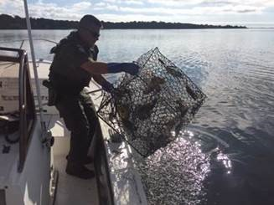
ECO Amato seizing illegal crab pots in Moriches Bay
Marijuana Thieves Discovered - Rensselaer County
On Thursday, September 8, ECOs Brian Canzeri and Zach Crain were working in Rensselaer County on a complaint of a marijuana growing operation when the officers located several plants in a secluded area. Following a hunch, ECO Canzeri decided to watch the area and within 10 minutes, the officers saw three subjects approaching. They watched from a few feet away as the men harvested most of the crop and began to carry it away. When ECOs Canzeri and Crain announced themselves, the subjects tried to run but were quickly taken into custody. The individuals claimed they had been out hunting squirrels but did not possess valid hunting licenses. They were charged with hunting without a license, and the marijuana offenses were turned over to New York State Police for additional charges. It is believed the subjects were actually stealing the marijuana from an unknown third party when apprehended. This was ECO Crain's third day on the job following his graduation from the 20th Basic Academy.
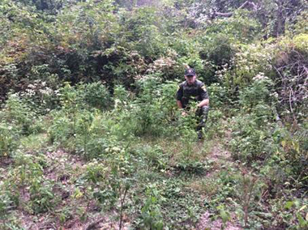
ECO Crain with an illegal marijuana growing operation.
Division Pipe and Drum Band at 9/11 Memorial - New York County
On Friday, September 9, the DLE Pipe and Drum Band participated in a NYPD Emerald Society 9/11 memorial in New York City. Commemorating the 15th Anniversary, the NYPD orchestrated a parade that included 18 pipe and drum bands from around the country, two brass bands, marching police agencies (both national and international), and antique police cars. It was the largest gathering of police officers in more than 100 years in New York City. The 1.5-mile parade route along Broadway went through the financial district to the police memorial near the North Cove. The detail was attended by Mayor Bill DeBlasio, NYPD Commissioner Bill Bratton, and other local dignitaries.
If you witness an environmental crime or believe a violation of environmental law occurred please call the DEC Division of Law Enforcement hotline at 1-844-DEC-ECOS (1-844-332-3267).

