DEC Environmental Conservation Officer Highlights

ECO Actions for Early to Mid-October
batter New York State Department of Environmental Conservation (DEC) Environmental Conservation Officers (ECOs) enforce the 71 Chapters of NY Environmental Conservation Law, protecting fish and wildlife and preserving environmental quality across New York.
In 2015, the 268 ECOs across the state responded to 25,000 calls and issued 22,000 tickets for crimes ranging from deer poaching and corporate toxic dumping to illegal mining, black market pet trade, and excessive emissions violations.
"From Montauk Point to Mount Marcy, from Brooklyn to Buffalo, the ECOs patrolling our state are the first line of defense in protecting New York's environment and our natural resources, ensuring that they exist for future generations of New Yorkers," said Commissioner Basil Seggos. "They work long and arduous hours, both deep in our remote wildernesses and in the tight confines of our urban landscapes. Although they don't receive much public fanfare, the work of our ECOs is critical to achieving DEC's mission to protect and enhance our environment."
Recent missions carried out by ECOs include:

ECOs Catch Illegal Deer Poacher - Allegany County
On October 2, the second day of archery season, Lt. William Powell found photographs posted online showing a deer shot with a crossbow next to a pile of corn. He forwarded the photographs to ECOs Jason Powers and Evan Laczi. The ECOs identified a suspect, who led them to a hunting camp in Belfast and claimed the deer was shot in Ohio, where baiting with corn is legal and the crossbow season is open. The ECOs dismissed the suspect's claims after learning he didn't possess a valid Ohio hunting license. The hunter then admitted to shooting a doe over bait during the closed season and showed them the crossbow, tree-stand, bait piles, and crossbow bolt, which was taken into evidence for the prosecution of the case. The suspect was issued multiple citations for hunting over bait and shooting a deer with a cross-bow during the closed season.
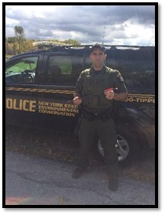
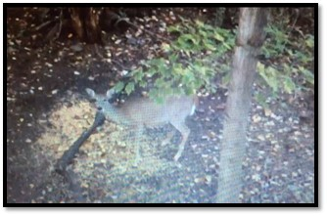
A photo of the illegally taken deer.

Sturgeon Restocking -- Monroe County
On October 7, ECOs Brian Shea and Eoin Snowdon assisted the US Fish and Wildlife Service (USFWS), US Geological Survey (USGS), and the DEC's Bureau of Fisheries with the stocking of Lake Sturgeon in the Genesee River. Once considered close to extinction due to a number of impacts on the species, sturgeon have been bolstered by stocking efforts over the past several years, yielding increases in Lake Sturgeon populations in Lake Ontario and its tributaries.
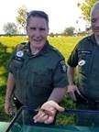
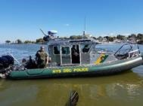
ECOs Shea, Snowden and
a DLE patrol boat stocking
Lake Sturgeon.

Youth Pheasant Hunt -- Genesee County
On October 9, members of Regions 8 and 9 Division of Law Enforcement hosted the 8th Annual Youth Pheasant Hunt at Pheasants on the Flats, a licensed shooting preserve in Batavia. The owner of Pheasants on the Flats closed the facility to the public to allow exclusive use of the premier cover for the young hunters and arranged to have guides and pointing dogs help with locating and flushing birds. The 10 participating boys and girls were extraordinarily successful, taking 18 birds before a cleaning demonstration by preserve staff. All of the young hunters left with pheasants ready for the oven, great memories, and a hobby to last a lifetime.
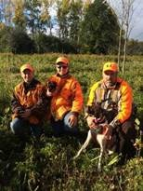
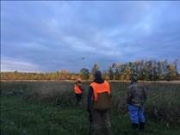
Youth pheasant hunt in Batavia.

Zurich Bog Search and Rescue -- Wayne County
While on patrol on October 10, ECO Kevin Thomas heard a call over the radio that a hiker and two small children were lost in Zurich Bog in the town of Arcadia. Zurich Bog is a 600-acre sphagnum swamp in Wayne County that has been designated a National Natural Historic Landmark by the National Park Service. ECO Thomas met New York State Troopers and Wayne County Sheriff's deputies at the head of the trail into the bog and spoke with the hiker's husband. Using her cell phone, the hiker said she had gotten lost more than two hours earlier, didn't know where she was, and that her cell phone battery was running low. She also had her seven and 10-year-old sons with her, trying to help them earn a Cub Scout badge. ECO Thomas had a trooper turn on his siren to see if the lost hiker could hear it, but she could not. A team of six officers then ventured into the bog, dividing into two teams when the trail split. A short time later, ECO Thomas' group heard a response from the lost hiker after calling out for her. Soon after, the officers found the family, tired but uninjured. They were escorted out of the bog through a marked trail.

Gator Selfies Come Back to Bite -- Westchester County
Over Columbus Day weekend, a Westchester County reptile exhibitor decided to do some creative fundraising and took one of his alligators to the Bear Mountain Overlook, a tourist attraction in the town of Cortlandt. He attracted a large crowd of on-lookers and proceeded to charge the tourists $5 each to hold the leash of the gator for pictures. Skeptical witnesses called the State Police, but the man and his gator left before the officers arrived. The case was ultimately turned over to ECO Dustin Dainack, who tracked the man down to a nearby warehouse, which held two alligators, multiple snakes, lizards, and turtles. ECOs Dainack and Craig Tompkins inspected the warehouse on October 11 and found that the animals were well cared for and that the defendant did, at one time, have a special permit to possess and exhibit the reptiles, but he had let all of his permits expire. ECO Dainack issued a summons for the possession of wild animals without a permit and a warning for allowing public contact for the alligator stunt.
Westchester Alligator

Make Sure It's Dead -- Ulster County
On October 11 at 11 p.m., ECO Joshua Sulkey received a call about a firearm being discharged in a residential area. The caller stated that the shot startled him and he could hear somebody say, "Make sure it's dead." ECO Sulkey met Shandaken Police on scene. A deceased black bear was found in the back yard. While interviewing the shooter, it was revealed that the bear was shot out of fear. The shooter stated that he had enough time to go from the side of the house to his vehicle to get his .30-30 rifle and then go to the back of the house and shoot the bear. Trash was strewn about in the backyard. ECO Sulkey advised the shooter that he would continue to have a bear problem if he didn't clean up the trash. ECO Sulkey issued several tickets to the individual for shooting the bear illegally and for discharging a weapon within 500 feet of houses.
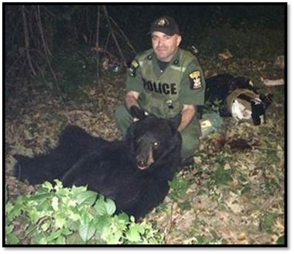
ECO Joshua Sulkey with the black bear.

ECO Union donates to Hunt of a Lifetime Foundation
The New York Conservation Officers Association (NYCOA) sent a $17,000 check during mid-October to the Hunt of a Lifetime Foundation, a nonprofit organization that grants hunting and fishing dreams for children 21 and under who have been diagnosed with life-threatening illnesses. This is the fifth consecutive year NYCOA has donated to the organization, with proceeds totaling more than $87,000 during that time. The money for this donation was raised at the annual NYCOA Hunt of a Lifetime Golf Tournament, held on July 9 at the Byrnecliff Resort in Varysburg, Wyoming County. The event is organized by ECOs Robert Peinkofer, Jim Hunt, and Don Damrath, with support from countless ECOs, DEC staff, and their families. More than 50 sponsors contributed to the event, including Cabelas, Genesee Beer, and JOH Marketing.
NYCOA was formed in 1986, and is a not-for-profit organization dedicated to the protection and wise use of our wildlife and natural resources. The membership of the Association consists of active and retired New York State ECOs and Investigators, and members of the general public. For more information, visit The NY Conservation Officers Association (link leaves DEC's website) website and The Hunt of a Lifetime (link leaves DEC's website) website.
If you witness an environmental crime or believe a violation of environmental law occurred please call the DEC Division of Law Enforcement hotline at 1-844-DEC-ECOS (1-844-332-3267).

