DEC Environmental Conservation Officer Highlights

ECO Actions for Mid-September
New York State Department of Environmental Conservation (DEC) Environmental Conservation Officers (ECOs) enforce the 71 Chapters of NY Environmental Conservation Law, protecting fish and wildlife and preserving environmental quality across New York.
In 2015, the 268 ECOs across the state responded to 25,000 calls and issued 22,000 tickets for crimes ranging from deer poaching to corporate toxic dumping and illegal mining, black market pet trade, and excessive emissions violations.
"From Montauk Point to Mount Marcy, from Brooklyn to Buffalo, the ECOs patrolling our state are the first line of defense in protecting New York's environment and our natural resources, ensuring that they exist for future generations of New Yorkers," said Commissioner Basil Seggos. "They work long and arduous hours, both deep in our remote wildernesses and in the tight confines of our urban landscapes. Although they don't receive much public fanfare, the work of our ECOs is critical to achieving DEC's mission to protect and enhance our environment."
Recent missions carried out by ECOs include:

Early Season Bear Baiting - Sullivan County
On September 10, the opening day of early bear hunting season, ECO Matthew Baker investigated a complaint of a bear being shot with the aid of pre-established bait in the town of Lumberland. Upon ECO Baker's arrival at the hunting camp, the bear was already field dressed and prepared for transport by the hunter. While at the camp, ECO Baker observed multiple empty donut boxes in a fire pit. ECO Baker located the stand nearby, along with a large pile of chocolate donuts and fresh blood on the ground. The hunter confessed to shooting the bear over bait, and ECO Baker ticketed him for hunting with the aid of bait and the illegal taking of a bear.

Busy Day on the Water - Westchester County
On September 11, ECOs Tom Koepf and John Helmeyer were on boat patrol on Long Island Sound near the cities of Rye and New Rochelle. The two officers were checking fishermen when they heard an air horn and noticed a man frantically waving from a light house and pointing into the water. The officers quickly responded and observed a man in a small wooden rental boat who was unable to start his motor. Intense winds had pushed the small vessel into the rocks on the island, creating a dangerous situation for the boater. ECO Helmeyer was able to maneuver the Division of Law Enforcement (DLE) vessel close enough to the small boat for ECO Koepf to grab a tow line and hook the two boats together. The small boat was towed back to City Island without further incident. However, the boater was found to have two short porgy in his possession and was issued a summons for taking porgy less than the legal size limit. After this encounter, the ECOs continued their patrol and by the end of the day had checked over 30 fishermen, issued 11 tickets for various violations, and seized 63 short porgy.
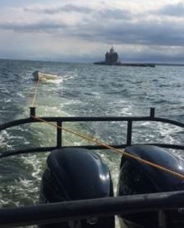
Distressed vessel Under Tow
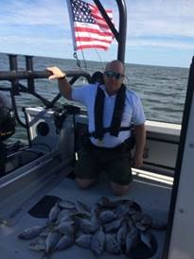
ECO Helmeyer with some of the
63 short porgy

Arrests for Illegal Disposal of Solid Waste - Orange County
Just after sunrise on September 12, ECOs Chris Lattimer, Myles Schillinger, Bob Hodor, Dustin Dainack, Will Chomicki, Charles Eylers, and Craig Tompkins arrested two men for unlawful disposal of solid waste on New York State Department of Transportation (DOT) property leased to Port Authority-Stewart Airport. The site is part of a greater investigation into large-scale solid waste violations. Both men were placed under arrest after tipping their separate loads of non-exempt construction and demolition debris, consisting of un-recognizable asphalt, brick, and concrete, as well as processed dimensional lumber, plastics, tile, marble, and drywall. Lt. Mike Bello had received information in August that roughly 40-yard tandem trailer loads of solid waste per day were being dumped onto Stewart Airport property. Surveillance was conducted over several weeks. On the morning of the arrests, the ECOs positioned themselves nearby to respond to any activity at the site. Lt. Bello and ECOs Schillinger and Chomicki maintained surveillance of the site. After two tractor trailers had dumped loads of waste, the officers responded to interview the drivers. Both drivers admitted they had delivered a total of at least 120 cubic yards each of the same non-exempt materials from a recycling facility in the Bronx. Both men were transported to the New York State Police in Montgomery, where they were interviewed, processed, and charged with misdemeanors. DEC staff from Habitat Protection and Solid Waste inspected the site. Representatives from DOT, Port Authority, and an environmental consulting company arrived on scene, as well as the general contractor who won the bid for the "clearing" project and the sub-contractor believed to be responsible for arranging the delivery of 10,000-17,000 cubic yards of waste. After being arrested and processed, the men were arraigned in Town of Newburgh Court and posted $400 cash bail. The drivers' cases will be heard on September 26, and the larger source and contractor investigation is continuing.
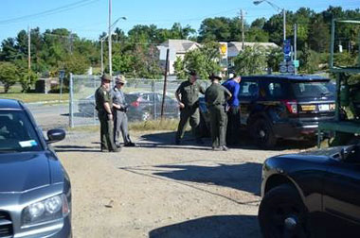
ECOs arresting the driver in an illegal solid waste disposal operation

Law Enforcement Career Day - Albany County
On September 12, ECO Kurt Bush attended a recruitment day with numerous other law enforcement agencies at the University of Albany campus. Approximately 175 students interested in law enforcement careers were present. ECO Bush met with students who were interested specifically in becoming an ECO. ECO Bush spoke to them about the requirements and process of becoming an ECO and answered questions. ECO Bush's focus was to encourage those interested in taking the ECO exam to sign up for the test before the October 5 deadline.
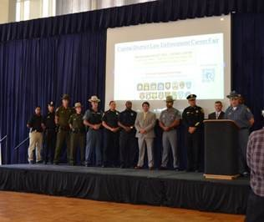
ECO Bush and other law enforcement at
SUNY Albany's career day

Marijuana/Cocaine Arrest - Orleans County
On September 12, ECO Vern Fonda assisted the Orleans County Major Felony Task Force with a search warrant located in a rural area in the town of Ridgeway. The search warrant was based on a large indoor marijuana growing operation at a rural residence. The warrant execution was overseen by the Orleans County Undersheriff and an investigator. Eighty marijuana plants were seized, along with 12 grams of cocaine packaged for sale, scales, a rifle, and other drug paraphernalia. One individual was charged with one count of criminal possession of a controlled substance in the third degree, one count of criminal possession of a controlled substance in the fourth degree, and one count of criminal possession of marijuana in the fourth degree, and committed to jail on $25,000 bail. A second individual was also arrested. A female was charged with one count of criminal possession of a controlled substance in the third degree, one count of criminal possession of a controlled substance in the fourth degree, and one count of criminal possession of marijuana in the fourth degree. She was committed to jail on $10,000 bail. The case will be heard in the Ridgeway Town Court in the coming weeks and the investigation continues. Additional charges are likely.

Illegal Deer Hunting - Tioga County
On September 14, ECO Stan Winnick was contacted by the Tioga County Sheriff's Department regarding an illegal hunting incident that had occurred the previous evening in the town of Richford. The Sheriff's department reported that a Richford resident heard a shot around 10:30 p.m. close to a car parked on Sears Road. The complainants were able to record the license plate and a description of the suspect's vehicle. A large, recently killed whitetail buck was found in an adjoining field. ECO Winnick met with the property owner and complainant at the scene and recovered a bullet from the deer carcass. ECOs Brent Wilson and Andy Kostuk assisted ECO Winnick with taking statements. ECO Tom Fernandez Winnick located the suspect's vehicle at the Marathon High School. ECO Winnick determined that the boyfriend of the vehicle's registered owner may have been involved in the shooting of the deer. The suspect admitted that his older brother had been driving the car and had shot the deer. ECO Winnick took written statements from both brothers and the older brother admitted to having shot the deer. The older brother was charged with discharging a firearm within 500 feet of a residence, taking deer during the closed season, taking deer with the aid of a motor vehicle, and hunting without a license. Both the bullet and the deer head were held as evidence.
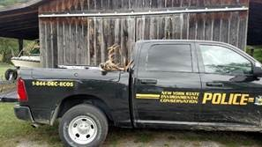
Illegally Poached Deer, Tioga County

Marijuana Eradication Efforts - Allegany, Cattaraugus, and Chautauqua counties
During late August and early September, ECOs Kevin Budniewski, Jerry Kinney, Chris Freeman, Jason Powers, Nate Mead, Russ Calanni, Darci Dougherty, and Lt. Don Pleakis assisted the Southern Tier Regional Drug Task Force, Allegany, Cattaraugus, and Chautauqua County Sheriff's departments, State Police, and the Army National Guard with marijuana eradication efforts. In Cattaraugus and Allegany Counties, a total of 639 illegal plants were seized along with 10 pounds of dried processed marijuana. Officers determined that there was an outstanding arrest warrant for a female subject found with the dried marijuana and she was arrested by State Police. Also in Chautauqua County, the State Police Aviation Unit observed a large number of marijuana plants near state land, resulting in the ECOs seizing 137 additional plants.
During late August and early September, ECOs Kevin Budniewski, Jerry Kinney, Chris Freeman, Jason Powers, Nate Mead, Russ Calanni, Darci Dougherty, and Lt. Don Pleakis assisted the Southern Tier Regional Drug Task Force, Allegany, Cattaraugus, and Chautauqua County Sheriff's departments, State Police, and the Army National Guard with marijuana eradication efforts. In Cattaraugus and Allegany Counties, a total of 639 illegal plants were seized along with 10 pounds of dried processed marijuana. Officers determined that there was an outstanding arrest warrant for a female subject found with the dried marijuana and she was arrested by State Police. Also in Chautauqua County, the State Police Aviation Unit observed a large number of marijuana plants near state land, resulting in the ECOs seizing 137 additional plants.
ECOs with seized marijuana plants in Region 9
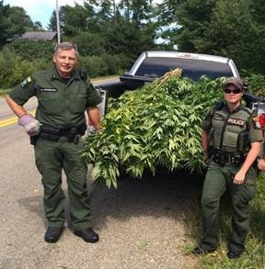
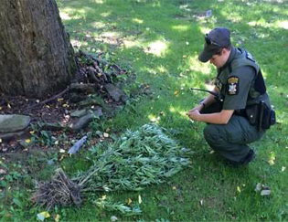
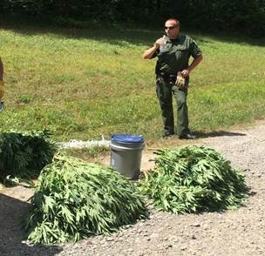
If you witness an environmental crime or believe a violation of environmental law occurred please call the DEC Division of Law Enforcement hotline at 1-844-DEC-ECOS (1-844-332-3267).

