DEC Environmental Conservation Officer Highlights

ECO Actions for Mid to Late August
New York State Department of Environmental Conservation (DEC) Environmental Conservation Officers (ECOs) enforce the 71 Chapters of NY Environmental Conservation Law, protecting fish and wildlife and preserving environmental quality across New York State.
In 2015, the 268 ECOs across the state responded to 25,000 calls and issued 22,000 tickets for crimes ranging from deer poaching to corporate toxic dumping and illegal mining, black market pet trade, and excessive emissions violations.
"From Montauk Point to Mount Marcy, from Brooklyn to Buffalo, the ECOs patrolling our state are the first line of defense in protecting New York's environment and our natural resources, ensuring that they exist for future generations of New Yorkers," said Commissioner Basil Seggos. "They work long and arduous hours, both deep in our remote wildernesses and in the tight confines of our urban landscapes. Although they don't receive much public fanfare, the work of our ECOs is critical to achieving DEC's mission to protect and enhance our environment."
Recent missions carried out by ECOs include:

Attempted Sale of Bald Eagle Parts Leads to Multiple Charges - Broome County
On August 13, off-duty ECO Andrew McCormick received a phone call reporting a deceased juvenile bald eagle found on a Binghamton sidewalk. ECO McCormick made arrangements with ECO Anthony Rigoli to retrieve the carcass. The eagle appeared to have been electrocuted on a power line. However, ECO Rigoli observed that its feet had been removed. Later that day, a business complainant advised ECO McCormick that a subject had come into a bait shop in Binghamton and attempted to sell the foot of a bald eagle. The complainant stated that he knew the possession of the eagle's foot is illegal and declined to buy it. Additionally, the complainant knew the subject lived in the village of Port Dickinson. Lt. Ric Warner obtained additional tissue samples from the carcass for a possible DNA match to the feet and to support a search warrant. On August 16, a search warrant was executed at the suspect's residence by Lt. Warner, ECOs McCormick and Templeton, and Port Dickinson Police Chief Douglas Pipher. The bald eagle feet, along with a primary wing feather, two bird nests, and a variety of protected bird species feathers were found and seized as evidence. The subject was arrested and charged with offering bald eagle parts for sale and the unlawful possession of additional protected wildlife parts. He was released with appearance tickets returnable in the Dickinson Town Court.
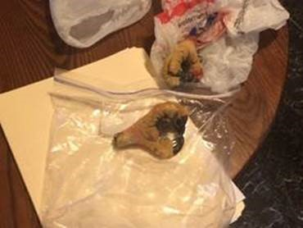
Illegally possessed bald eagle feet and wing feather.
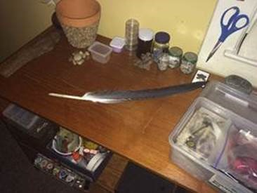

Illegal Clamming - Westchester County
On August 21, while patrolling the Long Island Sound near Playland Park in Rye, ECO Tom Koepf observed a male and female subject walking the shoreline. The male was in possession of a blue grocery bag; both individuals were holding digging tools. While interviewing the subjects, Koepf observed that the bag was full of clams. The subjects were informed that they were digging in uncertified waters. At least 130 clams were seized and both subjects were issued a ticket for taking shellfish from uncertified waters. The clams were then released back to the Long Island Sound.
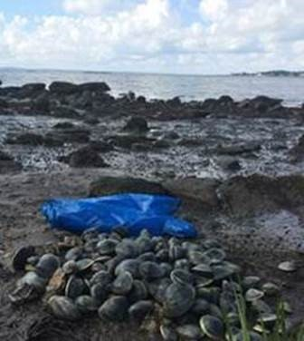
Clams illegally harvested from Long Island Sound.

Off-Duty Observation Leads to DWI Arrest - Seneca County
On August 18, while off duty, ECO Erik Dalecki was traveling north on State Rt. 414 in Hector when he was passed on a double solid line by an erratic driver in a SUV. ECO Dalecki remained behind the vehicle to record the license plate. He called the Schuyler County Sheriff's Office and relayed his location to the dispatchers. ECO Dalecki continued into Seneca County and was patched through to Seneca County 911. The SUV was swerving badly and almost hit a BMW traveling southbound at one point. ECO Dalecki continued to follow the SUV until it parked at the Dollar General store in Ovid. Seneca County Sheriffs and New York State Police arrived and ECO Dalecki assisted the responding officers when the driver began to leave the scene on foot. ECO Dalecki gave a supporting deposition to State Police and the driver of the SUV was arrested for DWI. The driver had a blood alcohol content of 0.26, more than three times the legal limit. The driver was also cited for numerous traffic infractions based on ECO Dalecki's observations and visual estimates of speed.

Boat Patrol on Saranac Chain Nets Speeders - Franklin County
ECOs James Cranker and Kevin Riggs were conducting a boat patrol on Lower Saranac Lake August 20 when they were contacted by DEC Saranac Islands Campground personnel relaying numerous public complaints about speeding boats in a narrow channel often congested with paddlers and motorboats. The ECOs set up a check area on the Saranac River between Middle and Lower Saranac Lake, a designated 5 MPH zone. Two vessels were issued tickets for exceeding 5 MPH within 100 feet of shore and several other vessels were given verbal warnings. The presence of the marked DEC police vessel on the waterway is a reminder to the boating public to operate their vessels in a safe manner. The ECOs were then dispatched to assist a boater who had stranded her pontoon boat on the rocks of Bluff Island on Lower Saranac Lake. A tow rope was secured and the pontoon boat pulled to deeper water.

Illegal Oyster Seizures - Suffolk County
ECOs in Brookhaven, Suffolk County, received information in late August that several subjects were diving for and keeping seed (undersized) oysters in Long Island Sound near Flax Pond. Commercial harvesters have been working that area for several years and the population of legal-sized oysters has decreased significantly. On August 18, ECOs Tim Fay, Mark Simmons, Kaitlin Grady, Landon Simmons, Jeff Hull, and Marcia Goodrich conducted a detail to address the complaints. They observed several boats working in the Flax Pond area and performed inspections both on the water and at the Port Jefferson boat ramp. Two of the three boats checked possessed oysters under the legal limit of three inches. The illegal oysters were seized and four subjects ticketed for violations, including possession of undersized oysters, failure to keep a digger's log, and failure to use a dive flag. That week, ECOs in Suffolk County seized approximately 5,000 illegal oysters.

Illegal Opossum Possession - Wayne County
On August 21, ECOs Shawn Dussault and John Stansfield received a complaint from a Wayne County veterinarian that an opossum was being kept at a food vendor's booth at the Wayne County Fair. The officers responded to the location and located the subject with his opossum. A check of the DEC licensing system showed that the opossum's owner was a valid Nuisance Wildlife Control Operator (NWCO) with an expired Wildlife Rehabilitator's license. Because the animal was being exhibited in violation of his NWCO permit, it was seized as evidence and transported to a local licensed rehabilitator. The subject was ticketed for unlawful possession of wildlife and violating the terms of his NWCO permit.

20th Basic Academy Final Patrol Tactics - Oswego County
On August 15-17 and 22-24, the recruits of the 20th Basic School for Uniformed Officers performed their final patrol tactics training exercises. This training simulates real-life scenarios the recruits may encounter after graduation and as they start their Law Enforcement careers with the Department of Environmental Conservation. Role players are brought in from around the state to act out the scenarios the recruits must complete; the recruits are graded on how they perform in each scenario. The training is spread out so the recruits get to experience scenarios in the daylight and nighttime. They encounter everything from a simple fishing license check to armed subjects in the woods. The 31 ECO and 17 Forest Ranger recruits graduated on September 2.
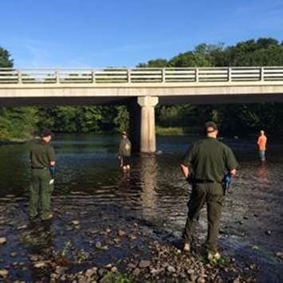
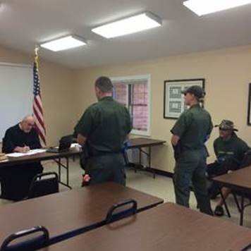
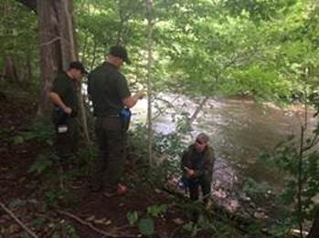
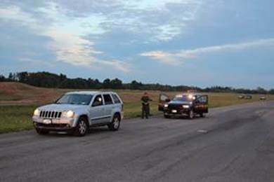
ECO and Forest Ranger recruits conducting training in
patrol tactics.
If you witness an environmental crime or believe a violation of environmental law occurred please call the DEC Division of Law Enforcement hotline at 1-844-DEC-ECOS (1-844-332-3267).

